Will You Join the Challenge?
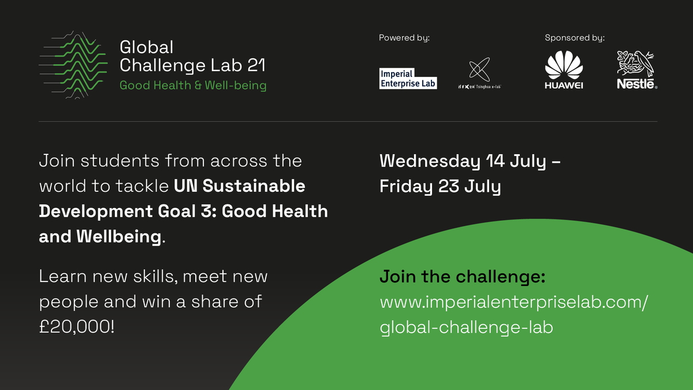

We’re excited to invite you to attend Global Challenge Lab.

Global Challenge Lab is a 10-day virtual programme of core and optional workshops, guest speakers and mentoring to help you come up with and develop innovative ideas.

We’re working with 10 global university partners to bring together hundreds of students and alumni to grow their international network, gain new skills and create new ideas that help achieve UN SDG 3: Good Health and Wellbeing. Students from all disciplinary backgrounds are encouraged to join!

At the end of the programme, the top teams from each track will have the opportunity to pitch their ideas and win a share of a £20K prize fund!

Register now: www.imperialenterpriselab.com/global-challenge-lab

CALL FOR MENTORS!
The Imperial College, London and Tsinghua University, Beijing are looking for dynamic professionals, entrepreneurs and faculty who are willing to support students and mentor them during the Global Challenge Lab slated for 14 to 23 July 2021.
The Global Challenge Lab seeks to bring together over 300 students to grow their international network, gain new skills and create new ideas that help achieve UN SDG 3: Good Health and Wellbeing. Students are encouraged to work in the following specific areas:
1. Mental Health & Non-Communicable Diseases
2. Women & Children’s Health
3. Communicable Diseases
4. Access to Healthcare.
Your role as a mentor:
- Offer your knowledge, insight, experience to students
- Guide and support the students and offer recommendations
- Suggest paths for exploration and widen the thinking or redirect/narrow the focus of students
- Offer contacts/connections/information and suggest goals for progress for the students
- Mediate in case of conflict or report any concerns to the programme organisers
- Refer students to another contact or mentor if you think they would be better suited to advise on certain topics
- Offer your time. A mentor is expected to give at least 4 hours of your time between Monday 19 July and Wednesday 21 July 2021
Interested mentors can email us on orid-ipatt@ug.edu.gh by Thursday June 24, 2021.
Thank you for your interest in the Global Challenge Lab – we hope to see you there!

