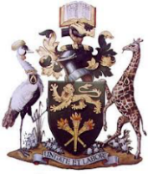
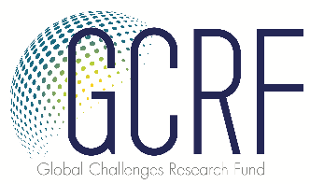

Invitation to the Event
Gender and Information Ecosystems in Climate Change Adaptation
A QR-GCRF research project funded by Research England/University of Leeds
Presentation and Discussion
of the Project Report from 2020 to 2021 Fieldwork in Ghana and Kenya
Lead Researchers:
University of Ghana: Professor Audrey Gadzekpo, Dr Gilbert Tieetah
University of Leeds: Professor Chris Paterson , Dr Lata Narayanaswamy, Professor Lee Edwards
University of Nairobi: Dr Jacinta Maweu Mwende, Dr Silas Oriaso Odongo

Date and Time
Date: 22nd of September 2022
Time: 10 am
You are invited to join us virtually.
Zoom Link: https://universityofleeds.zoom.us/j/87121894933
Project Description
This collaboration between UK, Ghanaian and Kenyan researchers sought to develop nuanced understandings of how local information ecosystems operate in a wide range of rural East and West African communities and to assess their implications for local women’s ability to combine indigenous and externally-sourced knowledge in their engagement with, and pursuit of, climate change adaptation activities.
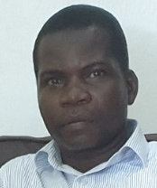
Key Speakers
Dr James Kapanya Nguzo is the county chief officer in charge of Lands and Energy at the County Government of Kilifi. He earned his Doctorate Degree (PhD) from the Jomo Kenyatta University of Agriculture & Technology in 2017. He holds two master’s degrees: an MA (Communication Studies) from the University of Nairobi and an MA (International Relations & Diplomacy) from Kenyatta University.
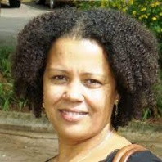
Dr Adelina Mensah is a Senior Research Fellow at the Institute for Environment and Sanitation Studies (IESS), University of Ghana (UG), with an interdisciplinary background in environmental sciences and a focus on ecosystems and the human dimensions that impact its management and sustainability. She has worked extensively with a number of national and international agencies on a range of climate change and environment-related projects.

