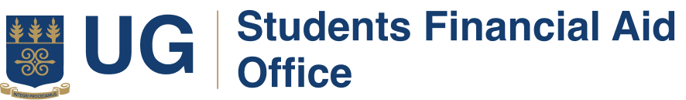

**VACANCIES FOR NATIONAL SERVICE PERSONNEL FOR THE 2025/2026 ACADEMIC YEAR**

Students Financial Aid Office (SFAO) is accepting applications for National Service Personnel for the 2025/2026 Academic Year.

**Requirements:**

1. Should be a Final Year Student
2. Minimum CGPA of 2.5
3. Be prepared to complete the Full Year Service.
4. Good knowledge in Microsoft Office (Word, Excel and PowerPoint).
5. Good verbal communication and writing skills.
6. Able to work under pressure and challenging environment.
7. Should be sociable, creative and a team player
8. Knowledge about website maintenance, updating data base and graphic designing will be advantageous.

Interested Applicants should write to:

***The Head***

***Students Financial Aid Office***

***GCB Building***

***P.O Box LG 25***

***Legon.***

*OR send an email to*[***finaid@ug.edu.gh***](mailto:finaid@ug.edu.gh)

**Applicants should include the following:**

1. Application letter (Must include Telephone Number, NSS Pin and Number)
2. Current Curriculum Vitae.
3. Copy of Student ID.

**Deadline:**

The deadline for submission is **on or before Friday, 13th June 2025 at 4pm. Only short-listed** applicants will be contacted.