PARTNERING FOR HEALTH PROFESSIONALS TRAINING IN AFRICAN UNIVERSITIES

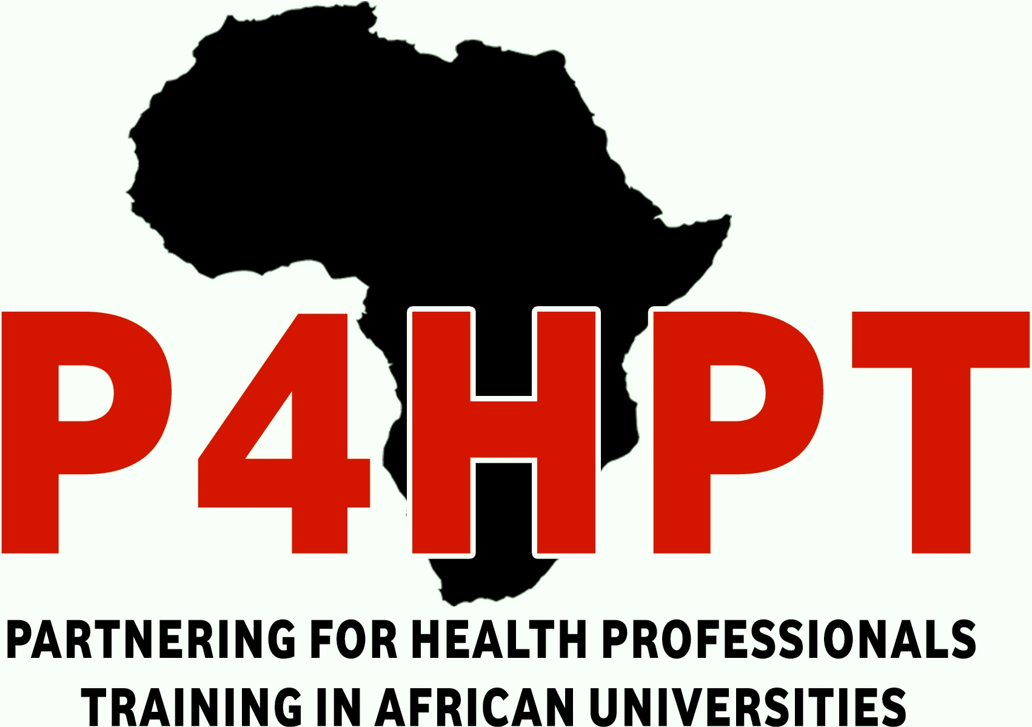

GUIDELINES FOR APPLICANTS
CALL CLOSES ON 5TH JUNE, 2017

This project has been funded with support from the European Commission

This communication reflects the views only of the author. The Commission cannot be held responsible for any use which may be made of the information contained therein
1.0 INTRODUCTION
This document is a guide to all applicants for scholarship under the Partnering for Health Professionals Training in African Universities (P4HPT) partnership. Reading this Guide is essential for a successful application procedure. All prospective applicants are therefore strongly advised to read these guidelines carefully before applying for the scholarship.

2.0 ABOUT THE INTRA ACP ACADEMIC MOBILITY SCHEME
The Intra-ACP Programme is a cooperation and mobility programme in the area of Higher Education, implemented by the Education, Audiovisual and Culture Executive Agency (EACEA). This programme builds on the African Union’s Mwalimu Nyerere programme for Africa. The programme aims to increase access to quality education that will encourage and enable ACP students to undertake postgraduate studies, and to promote student retention in the region along with mobility of staff (academic and administrative), while increasing the competitiveness and attractiveness of the institutions themselves. The Intra-ACP academic mobility scheme promotes co-operation between higher education institutions (HEIs) and supports mobility in Africa, the Caribbean and the Pacific (ACP) regions. It includes exchange and mobility at all levels of higher education, including a scholarship scheme. This means support for mobility for students (master, doctorate) and for staff (academic and administrative).

The Intra-ACP academic mobility scheme seeks to:
- provide access to higher education for students including those from disadvantaged groups;
- contribute to the improvement of the quality of higher education through the promotion of internationalization, and harmonization of programmes and curricula within participating institutions;
- enhance the international cooperation capacity of HEIs in ACP countries;
- enable students, academics and staff to benefit linguistically, culturally and professionally from the experience gained in the context of mobility to another country;
- enhance, in the medium-term, the political, cultural, educational and economic links between the participating countries.

3.0 P4HPT
The Partnering for Health Professional Training in African Universities (P4PHT) project is an academic mobility project which aims at building capacity of professionals with a view to expand the health workforce size in the target countries and subsequently improve well-being of communities through: improving health and quality of life of the communities through the prevention and treatment of disease; promoting healthy behaviours of the communities through Public Health Education; carry out surveillance and epidemiological studies for informed decision making; promote environmental Health through sensitization programmes; lead and manage health institutions effectively and efficiently; and, promoting research and advocacy for appropriate health policies.

The partnership is composed of;
- University of Ghana, Ghana (Coordinating Institution)
- Makerere University, Uganda
- Uganda Martyrs University, Uganda
- Stellenbosch University, South Africa
- University of Nairobi, Kenya
- Moi University, Kenya
- Eduardo Mondlane University, Mozambique
- University of Burundi, Burundi
- University of Juba, South Sudan
- National University of Lesotho, Lesotho
- Universite Catholique De Bukavu, Democratic Republic of Congo.

The institutions in this training partnership are well established in terms of infrastructure, academic resources and academic instructors. The project seeks to benefit different health professionals from the African region through the mobility scheme. The beneficiaries are envisaged to come from partner and non-partner institutions from Africa who would benefit from a wide range of health programmes/fields in Medical Sciences; Life Sciences; Public Health; and, Nursing and Midwifery.

The scheme is an opportunity for Africa HEIs to initiate mutual interaction and build high level professional human-resources capacity for quality training in health education and thus secure quality health services delivery. The training of Masters and PhDs students will enhance the production of vital human resource for the Africa region. Our expectation is to produce high quality graduates who are competent enough to be employable since there is already large vacuum of highly skilled labour force. With harmonisation of the programmes within the mobility, the graduates are expected to have equal employment and academic opportunities in any of the partner institutions.

The project has a target of providing scholarships to 18 students for doctoral studies, 43 students for Masters Studies and 8 staff exchanges among partner institutions

4.0 TYPES OF MOBILITY
A mobility flow is the mobility of individuals granted by the Intra-ACP scheme to undertake periods of study/research/teaching/training at one partner HEI in a country different from the one of origin. There are three (3) types of individual mobility. These are;
- Masters
- Doctorates
- Staff (Administrative and Academic)

5.0 TARGET GROUPS
A target group is a group of students/academic staff having the same characteristics regarding the institution/country of origin. Mobility flows are organised taking into consideration the target groups and the country of origin of the individuals concerned.
There are 2 target groups:

Target group 1:
These are nationals and/or residents registered/admitted in one of the HEIs that is a member of the Partnership or having obtained a degree by one of these HEIs. The mobility flow is therefore inside the partnership, from one partner HEI towards a partner HEI of a different country. Mobility is only possible to a HEI in a different country.

Target group 1 applicants must be nationals and/or residents in one of the following countries – Ghana, Uganda, South Africa, Kenya, Mozambique, Democratic Republic of Congo, Burundi, South Sudan, Lesotho and be registered/admitted or obtained a degree from any one of the following institutions; University of Ghana, Ghana; Makerere University, Uganda; Uganda Martyrs University, Uganda; Stellenbosch University, South Africa; University of Nairobi, Kenya; Moi University, Kenya; Eduardo Mondlane University, Mozambique; University of Burundi, Burundi; University of Juba, South Sudan; National University of Lesotho, Lesotho and Universite Catholique De Bukavu, Democratic Republic of Congo.

Target group 2:
These are nationals and/or residents registered/admitted in a HEI (not included in the partnership) of a country of the lot or having obtained a HEI degree (or equivalent) by an institution of a country concerned by the lot. The mobility flow is therefore from outside the partnership towards a partner HEI. Please see the FAQ section on the project website for details.

6.0 ELIGIBILITY
6.1 Eligibility Criteria for Students
To be eligible for the Scholarship, masters and doctoral students must:
- be a national and/or resident in any of the eligible countries, covered by the relevant lot;
- be registered/admitted at one of the HEIs within the Partnership at the time of the application for a scholarship or have obtained a degree from one of the HEIs of the partnership; or be registered/admitted in a HEI (not included in the partnership) of a country of the lot or having obtained a HEI degree (or equivalent) by an institution of a country concerned by the lot; and
- have sufficient knowledge of the language in which courses are offered at the host HEI.

6.2 Eligibility Criteria for Academic or Administrative Staff
The academic and administrative staff, hereafter referred to as “staff” mobility offers additional opportunities of personal and professional development, through the possibility of doing practical training, researching and teaching in a partner institution. This type of mobility always involves the active participation in teaching, research and in the daily life office activities. By submitting his/her application the applicant must be aware not only of the eligibility criteria but also of the tasks that the mobility will demand. In order to be eligible, staff, must:
- be a national and a resident in any of the eligible countries covered by the relevant lot;
- have not benefited in the past from an Intra-ACP scholarship for the same type of mobility;
- work for full time in a partner University;
- have sufficient knowledge of the language of the courses or of one of the languages currently spoken in the hosting countries;
- Mobility assignments must be based on agreements between the members of the partnership. The home and host HEIs and the individual staff must agree on the programme of the lectures to be delivered by the visiting staff (in the case of academic staff), on the research activities, on the type of training to be followed or on type of administrative tasks to be undertaken.

7.0 CATEGORIES OF SCHOLARSHIPS
The following scholarship categories are available:

7.1 Full degree scholarships for Masters and PhD students
Students who meet the criteria will be able to apply for full degree scholarship for completion of a Masters or PhD degree at one of the higher education institutions in the partnership.
The programmes offered in each of the partner institutions are summarized in the table below;
PROGRAMMES | PARTNER INSTITUTIONS OFFERING PROGRAMME
PROGRAMMES | Univ. of Ghana | Makerere Univ. | Uganda Martyrs Univ. | Stellenbosch Univ. | Univ. of Nairobi | Moi University
MSc./Mphil in Applied Health Social Sciences | √
M. Phil Anatomy | √
PhD Public Health | √
PhD Health Sciences |  | √
Master of Nursing (Midwifery and Women’s Health) |  | √
Masters of Public Health (MPH) |  | √
MSc. Health Services Management |  |  | √
PhD Medical Microbiology |  |  |  | √
Masters in Cytopathology |  |  |  | √
Masters in Microbiology |  |  |  | √
Masters in Virology |  |  |  | √
PhD Haematological Pathology |  |  |  | √
Masters of Dental Surgery in Peadiatric Dentistry |  |  |  |  | √
Masters of dental surgery in Prosthodontics |  |  |  |  | √
Master of Dental Surgery in Periodontology |  |  |  |  | √
Masters of Dental surgery in Oral and Maxillofacial surgery |  |  |  |  | √
MSC International Health Research Ethics |  |  |  |  |  | √
Master of Immunology |  |  |  |  |  | √

7.2 Academic and administrative staff mobilities
Staff employed at higher education institutions of the partnership will be able to apply for short term mobility opportunities which could include benchmarking exercises, sabbatical research periods, guest lecturing, curriculum development, knowledge and resource sharing trips etc. on the basis that both institutions support the trip.

8.0 SCHOLARSHIP PACKAGE
The following are covered by the scholarship;
- One Round trip flight ticket and visa costs (using a preferred travel agent and calculated against direct linear distance)
- A monthly subsistence allowance payable on a regular basis during the mobility period

Mobility Type | Monthly subsistence allowance
Masters | € 600
Doctorates | € 900
Staff | € 1,000

- Direct participation costs such as tuition fees, registration fees and service fees where applicable.
- Comprehensive Travel Insurance (Health, Accident and Travel)
Accommodation expenses will be covered by the scholarship recipient and can be done from the monthly subsistence allowance. However, the host institution will assist in identifying a suitable accommodation for the scholarship holder.

NB: Due to the project end date, PhD students will have the scholarship package for 24 months.

9.0 APPLICATION PROCESS
To benefit from the mobility, interested persons are to complete two (2) applications.
- Apply for Admission
- Apply for Scholarship
Selection for Admission and Scholarship are done by two different bodies hence the applicant must ensure that they apply to both the institution and the scheme.

9.1 Applying for Admission
Applicants are to visit the respective hosting institution websites for directions on how to apply for admission. You may also contact the Institution representatives/contact persons listed in the table below for guidance.

Institution | Application website | Institution Contact Address
University of Ghana | http://admission1.ug.edu.gh/freshstudents/index.php/graduate-admissions/regular-full-fee-paying.html | Prof. Richard Adanu (rmadanu@ug.edu.gh)
Makerere University | http://mak.ac.ug/admissions/application-procedures | Prof. Isaac Okullo (iokullo@chs.mak.ac.ug; okullo2000@yahoo.com)  Prof Andrew Okwi (andrewol@chs.mak.ac.ug)
Stellenbosch University | http://web-apps.sun.ac.za/eAansoek2/alg.jsp?Tl=1 | Prof. Andrew Whitelaw (awhitelaw@sun.ac.za; rte@sun.ac.za )
Uganda Martyrs University | http://www.umu.ac.ug/index.php/how-to-apply/ | Prof. Maniple Everd Bikaitwoha (everdmaniple@umu.ac.ug)
University of Nairobi | http://www.uonbi.ac.ke/admission/graduate | Prof. Loice Gathece (gathece@uonbi.ac.ke)
Moi University | http://www.mu.ac.ke/newio/index.php/admission-process2 | Prof. David Ayuku (ayukud@gmail.com)

9.2 Applying for Scholarship
Applications for scholarships must be made by completing the P4HPT SCHOLARSHIP APPLICATION FORM available at the project website (www.ug.edu.gh/p4hpt)

Application submission Process
To fill in the Application Form, the following steps must be considered:
- The applicants should have a valid e-mail address.
- To access the form, the applicants should visit the project website at www.ug.edu.gh and click on ‘Apply Now’.
- The applicant is expected to download and complete the application form.
- All sections of the application form must be completed. The applicant must answer truthfully to all questions so as to ensure the fulfilment to all general eligibility criteria.
- All required documents must be attached to the application form and saved as one document in pdf format.
- Completed application forms with attached documents are to be emailed to p4hpt@chs.edu.gh with email subject – “2017 P4HPT APPLICATION – (Applicants’ name)”
- Please include a valid e-mail address in your application for communication purposes. Do not include in the application form the e-mail of another colleague or friend that is also applying as the communication of results will be done exclusively by e-mail and this could generate problems in interpreting the selection results.
- The applicants should only have one valid application at the beginning of the selection procedure.

Completed application forms should consist of the following data:
- Personal contact information of the candidate
- Curriculum Vitae
- Proof of nationality
- Fulfilment of relevant requirements for different target groups and mobility
- Proof of sufficient knowledge of the tuition language at the host university (for students only)
- At least 3 Letters of Recommendation/Reference
- Choice of course/s and/or study programme
- Preferred host institution

10.0 SELECTION PROCESS
After the application deadline, the partnership will review all received applications. Only complete applications will be considered for selection. Your application is complete if you have uploaded all the requested documents. If you have given incorrect or misguiding information in your application, this will be a reason to withdraw your application/grant.

11.0 EVALUATION CRITERIA
Applications will be evaluated based on the under listed criteria
- Academic merit
- Motivation for the mobility period
- Sufficient knowledge of the tuition language at the host University
- Learning Agreement or Study Plan (for master's students)
- Positive reference/recommendation
- Research/Teaching Plan (for PhD and academic staff)

Administrative Criteria
Additional administrative criteria will include;
- Relevance of the mobility for both the host university and the home university
- Equal geographic representation of the partner universities in the mobility scheme
- Equity considerations for designated groups

12.0 ASSESSMENT PROCEDURE
- Assessment will be performed by members of the Advisory and Selection Committee of the P4HPT partnership
- Each assessor will be required to sign an absence of conflict of interest declaration

13.0 INFORMATION TO APPLICANTS
- All applicants will be notified via e-mail
- All applicants not selected for the programme will be notified immediately after the selection decision has been made. Notification will include:
- The results of the selection
- The procedure to follow for an appeal to the selection decision

- For the selected candidates the notification will include:
- Instructions for further steps (visa guidelines, etc.)
- A model of the Student Agreement
- As well as any other relevant information

14.0 SUPPORT TO SCHOLARSHIP HOLDERS
Support to P4HPT scholarship holders will be both academic and administrative.

- Academic Support
Academic support will be provided to all P4HPT scholarship holders at each partner institution. The academic support provided will include;
- Setting up agreements with students on an individual work programme and on the workload required to pass any examinations or other forms of assessment (i.e. student agreements, learning agreements).
- Assuring the P4HPT scholarship holder (all types of mobility) benefits of the same working conditions and the same health and security protection levels similar to the local students and members of the academic community.
- Providing mentoring for scholarship holders
- Keeping student records of scholarship holders
- Arranging supervisors for research students
- Arranging field trips for research students where necessary
- Providing counselling for future career and work placements
- Awarding degrees to P4HPT scholarship holders upon successful completion of the degree programme

- Administrative Support
- TRAVEL
The co-ordinating institution will be responsible for booking and paying the grantees’ two- way travel ticket between the scholarship holder’s home university’s city and the host University City having as reference the maximum amounts foreseen by the EU for each travel. In case the home or host institutions are not located in a city with an international airport, the scholarship holders must keep the invoices of the local transportation, such as, for example, bus, subway, or train used to undertake the travel, so as to be able to submit a reimbursement request to the coordination.

This request should be made as soon as possible, in a proper form and should be accompanied by the scanned original invoices of payment. The original documents must be sent to the co-ordinating institution that will analyse the possibility of reimbursement. In cases of long stay (more than 10 months) it will not be possible to buy the 2way ticket immediately. Therefore, all reimbursement requests should be put on hold until the co-ordinating institution can buy the return ticket and use the leftovers to reimburse other travel expenses. Taxi expenses are strongly discouraged. The co-ordinating institution will carefully analyse each expense, not considering eligible taxi expenses between cities if there is other less expensive means of transportation. All the reimbursements will be made considering the exchange rate of the day in which the expenses were done. In case the scholarship holders wants to change the flight dates for personal reasons this may be allowed as long as the return date is not before the foreseen ending date of the programme of activities/mobility. In this case, all changes should be paid by the scholarship holder and not by the project. Please note that it will not be possible to reimburse any further accommodation expenses or a vacation travel to the grantee’s home country.

- INSURANCE
The co-ordinating institution will provide directly to each scholarship holder a comprehensive health, travel and personal accidents insurance valid in the host country, in line with the demands of the EACEA – Education, Audiovisual and Culture Executive Agency. This insurance will be valid from the moment and place of departure to the mobility period until the return, when the mobility period is over. Such insurance may not be valid in other countries/regions therefore scholarship holder must take this into consideration when travelling during the mobility period.

- SCHOLARSHIPS
A scholarship contract that defines all the conditions, benefits and responsibilities related with the project implementation as well as the schedule of payments covered by the scholarships will be signed by each institution, the scholarship holder and the Co-ordinating institution. Only after this document is signed will the scholarship be valid. This will be done directly by the host institution: the grantee will receive the first two payments in the first instalment to help in the installation procedures. The following monthly scholarships will be paid into the grantee’s bank account. Monthly subsistence allowance can only be paid as from the month of arrival and covers each full month of the mobility, based on academic grounds. If a portion of a month is more than 15 days a full month allowance is to be paid (for example: for academic reasons the mobility duration is 9 months and 15 days only 9 months allowance should be paid, If the duration is 9 months and 16 days then 10 months allowance should be paid.)

- WORKING CONDITIONS
The host institution will assure that the scholarship holder (all types of mobility) benefits of the same working conditions and the same health and security protection levels than the local students and members of the academic community. The host institution must provide support to the scholarship holder, particularly regarding the resolution of any administrative procedures required by the host countries’ authorities. The scholarship holder should immediately inform the co-ordinating institution by e-mail in case there is lack of necessary support by the host institution.

- MANAGEMENT OF SCHOLARSHIP FUNDS
17.1 In Case Of Interruption
A scholarship can be put on hold if the student has to temporarily leave the host institution following duly justified and well documented reasons (i.e. illness etc.). In that case the scholarship payment must be interrupted until he/she has returned to the host institution and can actively participate in the activities. If despite the temporary absence the scholarship holder can catch up on the study/research without extending the originally agreed scholarship duration, the monthly allowances corresponding to the period of interruption could be paid to the candidate if agreed among the partners and notified to the agency.

If the reasons are due to force majeure, the absence of the scholarship holder would lead to an extension of the originally agreed eligibility period in order to finalise the mobility concerned. Hence, the coordinator must send to the Agency a duly substantiated request to extend the eligibility period of the Grant Agreement in question. This request will be treated as an official amendment.

If the interruption is due to academic reasons, such as students having to study or carry out research or other activities for a short period at the home country or at other countries which are not the ones of the institutions included in the partnership, the monthly allowance is not paid for this period. Mobility flows are not allowed between institutions placed in the country of origin/nationality of the individual(s) concerned. The interruption can take place only after 6 consecutive months of study at host institutions.

The mobility for staff can be split in several shorter periods for a minimum of one month each.

17.2 In Case of Drop-Out
If a scholarship holder decides to withdraw before or during the study period, the partnership has the possibility to replace her/him from the reserve list, provided that it is within the deadlines for start of the mobility of the respective cohort. If such replacement is not possible, the remaining monthly allowance and participation costs could be reallocated to another scholarship holder.

18.0 INFORMATION AND SUPPORT
Information on P4HPT can be obtained from the partnership’s website: www.ug.edu.gh/p4hpt

19.0 PROJECT SECRETARIAT
The Project has created a project secretariat responsible for the implementation of the tasks seeking the preparation and development of the P4HPT scholarship programme, in strict co-operation with the EACEA and the European Commission.

Project Secretariat Contact Information

Physical Location
School of Public Health
University of Ghana, Legon campus between the University stadium and the Noguchi Memorial Institute for Medical Research
Postal address
P4HPT Secretariat
Dean’s Office
School of Public Health
University of Ghana
P. O. Box LG 13
Legon, Accra - Ghana

Email Address
Coordinator: rmadanu@ug.edu.gh
Administrator: feyanumu@ug.edu.gh
Project email: p4hpt@chs.edu.gh

TRAINING THE NEXT GENERATION OF HEALTH PROFESSIONALS IN AFRICA!!

