UNIVERSITY OF GHANA



USER MANUAL

*FINANCE MODULE* PROCUREMENT MANAGEMENT

INTEGRATOR 1.0

# FINANCE DIRECTORATE JULY, 2015

**TABLE OF CONTENT**

1. STOCK / INVENTORY PROCUREMENT 3
   1. SUMMARY OF PROCUREMENT AND ACCOUNT PAYABLE ACTIVITIES 3
   2. MAINTAIN REQUISITIONS (FPMO1-1) 3
   3. BUYER REQUISITION SCHEDULING (FPMO1-2) 5
   4. BUYER QUOTATION MAINTENANCE (FPMO1-3) 6
2. HOW TO CORRECT AN ERROR REPORTED ON QUOTATION MAINTENANCE 11
3. APPROVAL OF REQUISITIONS (FPMO1-5) 12
4. PLACING ORDER FROM REQUISITION (FPMO2-6) 13
   1. FPMO2-1 (MAINTAIN ORDERS) 13
   2. FPMO2-6 (PLACE ORDER FROM REQUEST) 14
5. RECEIVING ORDERS/GOOD INTO STORES (FPMO3-1) 16
6. SEARCH FOR A DOCUMENT (FPMO1-8) 17
7. MAINTAIN INVOICE/CREDIT NOTE (FPMO5-1) 18
8. CREDIT NOTE AND PRE-PAYMENT TRANSACTION 21
   1. QUERY CREDITOR TRANSACTIONS 22
9. APPROVING AN INVOICE 23
10. CASH FLOW GENERATION-FPMOPD-1 24
11. CHEque PRINTING 25
12. PAYMENTS THROUGH THE IENABLER 26
13. VALIDATING PAYMENT REQUISITIONS 28
14. APPROVING THE PAYMENT REQUISITION ON THE IENABLER 31
15. LOADING THE DOCUMENT FOR PRINTING (FCTO-6) 32
    1. PRINTING OF CHEQUES (LFCTO-1/2) 34
16. STOCK ISSUES AND STOCK RETURNS 35
    1. ISSUING REQUESTED STOCK 35
    2. RETURNING OF STOCK 37

# STOCK / INVENTORY PROCUREMENT

* 1. **SUMMARY OF PROCUREMENT AND ACCOUNT PAYABLE ACTIVITIES**

1. Store keeper places purchase order (PO) request on FPMO1-1 (Maintain Requisitions).
2. Head of Procurement schedules the work on FPMO1-2.
3. Procurement advertises for quotations and loads invoices on FPMO1-3 (Buyer Quotation Maintenance).
4. Selection is done for qualifying supplier using FPMO1-3
5. Approval of the selected creditor and items by Head of Department on FPMO1-5
6. Head of Procurement places order with the selected vendor on PMO2-6
7. Storekeeper receives the goods supplied using FPMO3-1, generate and print Goods Received Voucher (GRV), and attach it to the invoice.
8. Storekeeper issues items out to requesters on FPMO4-1.
9. Store issue report printed on FPMOR4-11.
10. Account Payable processes invoice for payment on FPMO5-1

## MAINTAIN REQUISITIONS (FPMO1-1)

This menu is used to place a Purchase Order (PO) with the Procurement Unit for the purchase of store items. The store keeper by this request, inputs the items needed to replenish the stores when the items reach the minimum stock level. Use the menu option **“FPMO1-1” (Maintain requisition).** The processes are as follows:

* + - Tap to generate **“Requisition Number (RY….”** for the request and note it on the

### “Invoice/Quotation”

* + - Move to **“Next Block”** and enter details as shown below:

|  |  |  |  |  |  |  |  |
| --- | --- | --- | --- | --- | --- | --- | --- |
| **Request Type** | **Item type** | **Item** | **Qty** | **Unit** | **Description** | **Unit Price** | **Total** |
|  |  |  |  |  |  |  |  |

* + - At item type click on the three dots **“Item Type”** change **‘’N’’-Non defined item** to

### “S’’ - Stock Item

* + - Right Click on **“Item type”** and click on “request type”

FPMO1-1 – Maintain Requisitions

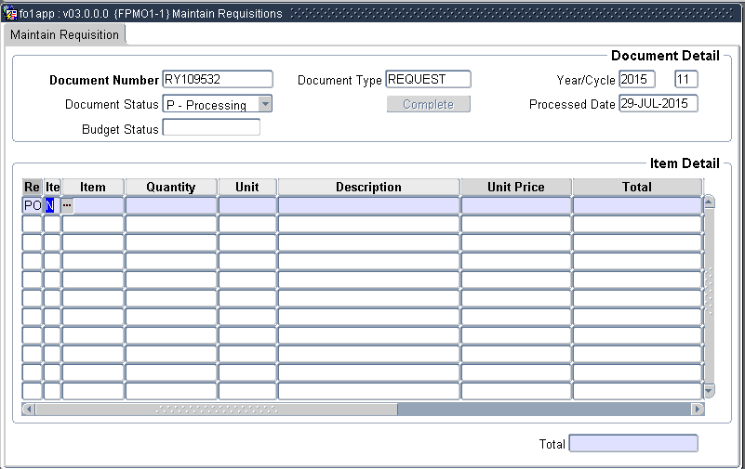

* + - Select **“PO - Purchase Request Order”** and **“Click”** on **“OK**
    - Tab to “**Item”** and click on the three dots to search for the items needed by using the

**‘’find’’** or enter the item number straightaway.

* + - Tab to “**Quantity”** and enter the required quantities e.g. 20
    - Use the down pointing cursor key  to move to next line and repeat the above steps for other needed items or the list on the same invoice.
    - When you are done with all the items, **click** on **“Previous Block”** icon on top of the screen.
    - **Click** on **“Complete”** to end the process. This opens another page which is used to run reports on status of the request.
    - **Click** on View. This is to check whether any errors have been reported.
    - **Click on “OK**” on the Pop-up for the request to move to the next stage.
    - To determine if all is correct this will show **(Status: Document R RY…** **Has**

**status buyer/cheque validation**.

## BUYER REQUISITION SCHEDULING (FPMO1-2)

Requisitions maintained on FPMO1-1 can be assigned and/or reassigned from one buyer to another by the Procurement Officer for further action on FPMO1-3. This process is called **Buyer Requisition Scheduling** and it is performed on **FPMO1-2.**

Below is a screen shot of the menu.

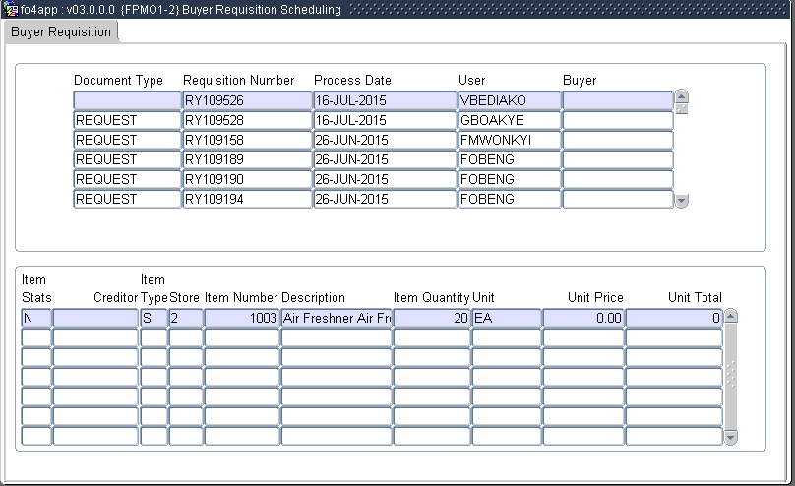

To assign or reassign a particular requisition on FPMO1-2;

* + - Click on “Enter query”
    - Type in the Requisition Number eg RY109565
    - Click on “Execute query”
    - This will show details such as
      * Name of the person working on the requisition
      * Items for which requisition is being done
    - Enter the username of a buyer to assign requisition, or change the name of the buyer to reassign the requisition.
    - Click on save when completed.

## BUYER QUOTATION MAINTENANCE (FPMO1-3)

This functionality is used to capture the quotations received from vendors of the items. After capturing, the supplier with the best offer in terms of quality, price, delivery period, etc can be selected. The user performing this function must have a buyer privilege.

The quotation maintenance procedure is as follows:

Enter the **“MENU OPTION”** FPMO1-3. This opens a screen shot as shown below:

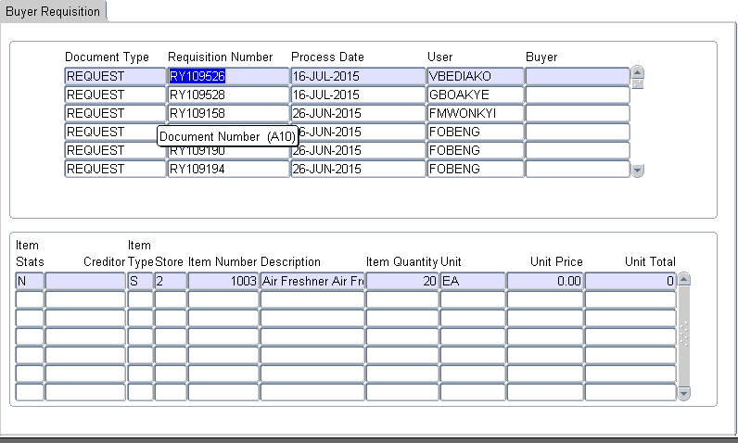

* + - The requisition numbers generated by the different storekeepers will be listed under the heading **“Requisition number”**
    - Search for the number as written on the invoice. i.e. **“Requisition Number”** or **“RY….”**
    - Tab to **“highlight”** the relevant requisition number.
    - Right Click on it and select **“Maintain Items”.**

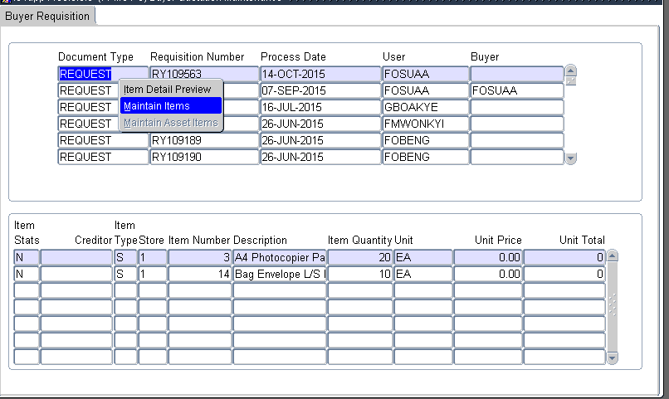

This opens another window or screen with the list of items requested by the storekeeper as shown below:

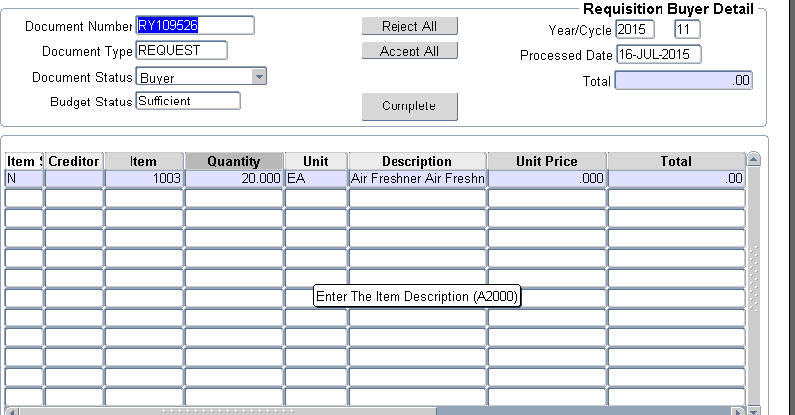

* + - Click on “Next Block”
    - With the cursor in the field under **“Creditor”,** right click and select **“Maintain item quotation”.** The screen shown below opens.

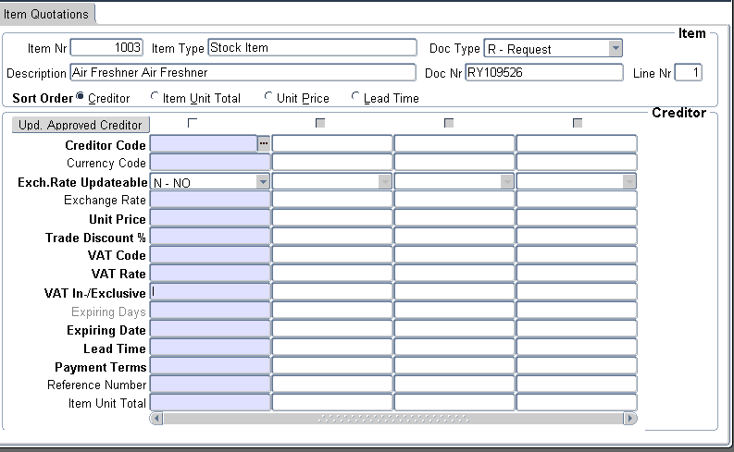

* + - Enter the relevant details as provided on the invoices from the suppliers.
      * Creditor code – as defined on the system. Click on the three dots (…) to search for the creditor code.
      * Tab to Unit price and enter the unit price of the item as stated on the invoice.
      * Tab to VAT code – select from the list of values by clicking on the dots (…) to open the list e.g. 17.5%.
      * VAT rate – will automatically populate from the selected VAT code.
      * VAT Inclusive / Exclusive - Indicate whether the price quoted is VAT Inclusive / Exclusive. Maintain the default **‘’I’’** for Vat inclusive price and type **‘’E’’** for Exclusive.
      * Expiry date – Validity period of the invoice.
      * Lead time –How long will it take the creditor to deliver the items when order is placed.
      * Payment terms – select from the list of values e.g. 006 for payment terms within 30 days.
      * Reference Number - Enter the reference number as stated on the invoice

### Repeat the above processes for all the quotations received for that particular item

**by moving to “next record”**

* + - Once all the quotations have been captured as prescribed above, check the box at the top of the column to select the winner of the bid.
    - Click on **“update approved creditor”** to complete the creditor selection process for that particular item.
    - Repeat the above processes for all the required items.
    - Click on Save and Exit.
    - On each of the line items, allocate the units account type as follows:
      * Click on Next block
      * On the selected item line, tab to Cost Centre or Account Code and right click on it

### Select “Financial Item Detail” as shown below

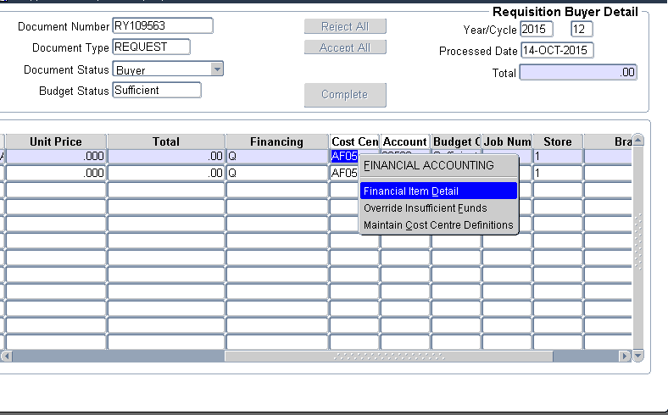

This opens another screen as shown below.

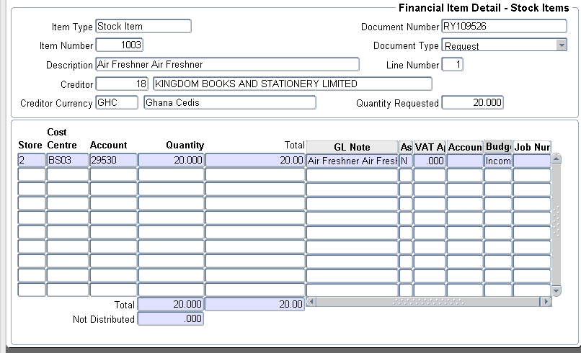

* + - * Tab to Account type and Select the appropriate Account Type e.g. APAH for SAHS
      * Use the  pointing arrow and do likewise for all the other items
      * Click on Save to commit and Exit
      * Check all entries to ensure that invoice total match with system totals. Where there are differences, it must be investigated.
    - Click on “Previous Block” and do the following:
      * Click on **Accept all** to accept (or **Reject all** to reject the entire work).
      * Click on “Complete” to finalize the quotation maintenance. View the report that follows.

**NOTE**

Once completed, all errors will be listed under the following headings:

* + - If no errors are identified, it will show first approval, thus ready to be approved by the person authorized to do so.

## HOW TO CORRECT AN ERROR REPORTED ON QUOTATION MAINTENANCE

In case there is an error report after completing quotation maintenance (e.g. if the account type is not inputted), it can be rectified as follows:

* Use MENU FPMO1-1(Maintain Requisitions) which has a screen shot shown below:

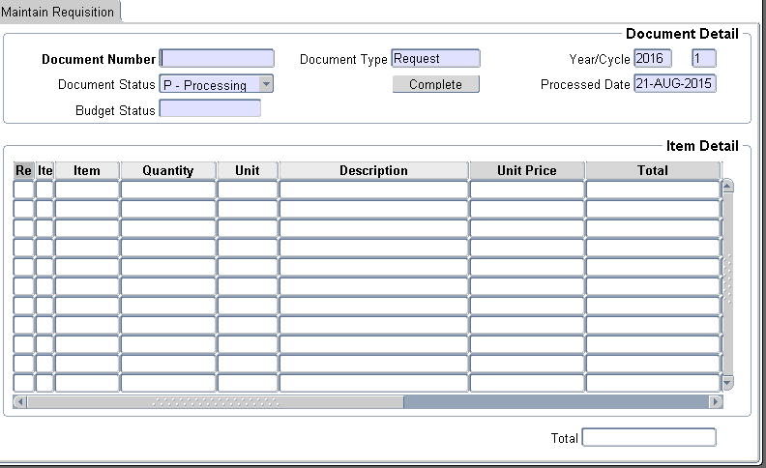

* Enter query
* Enter the requisition number
* Execute query
* Move to Next block. This will show the following:
  + RE: PO (Purchase Order)
  + Item type: S (Stock)
  + Item: Name of items requested for
  + Quantity: Amounts ordered for
  + Unit: Unit of order
  + Description
  + Unit price
  + Total price (Unit Price x Quantity)
  + Cost Centre & Account Code
  + Budget Indicator
  + Store number
  + Creditor name
* On the Cost Centre or Account Code
* Right click to show the following:
  + LOV Cost Centre/ LOV Account Code
  + Financial item detail
  + Override insufficient funds
  + Etc
* Click on Financial item detail (assuming the error is Account Type)
* Scroll to Account Type and Enter the appropriate one e.g. AP.
* Save, exit and click on “Complete”
* View the report again to see if the errors are fixed.
* Once no errors are reported, it is ready for approval.

## APPROVAL OF REQUISITIONS (FPMO1-5)

After the quotations have been maintained by procurement officer, the selected invoices have to be approved by an authorized person as follows:

Use MENU OPTION FPMO1-5 (Requisitions Approval) with a screen as shown below:

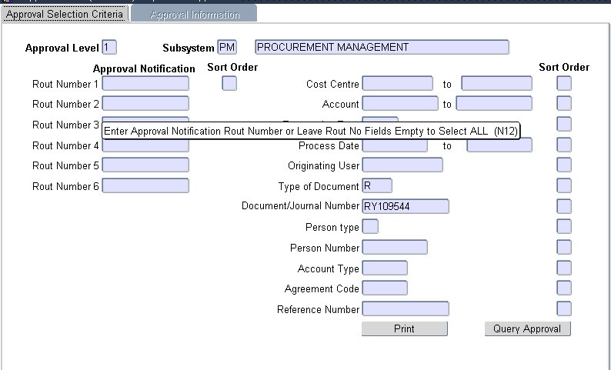

* Enter the approval level of the person approving the requisition (normally “1”)
* Tap to “Document / Journal Number”
* Enter the Requisition number (“RY” number generated from FPMO1-1)
* Click on “Query Approval”. This produces a screen as shown below:

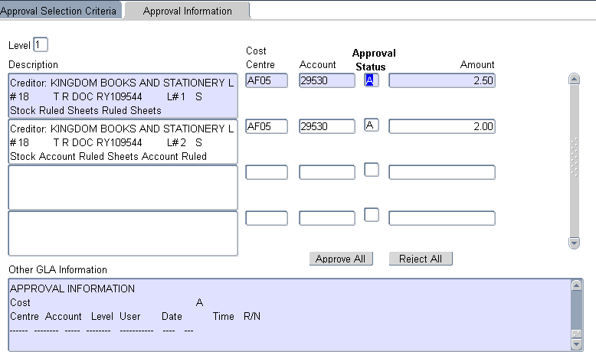

* Click on “Approve All” or “Reject All” depending on the action that needs to be taken.
* Click on save to approve or reject if the approval status is “A” or “R” respectively.

## PLACING ORDER FROM REQUISITION (FPMO2-6)

Order placing can be done in two ways:

1. Through Menu Option FPMO2-1(Maintain Orders)
2. Through Menu Option FPMO2-6 (Place Order From Request)

## FPMO2-1 (MAINTAIN ORDERS)

This is used to process direct orders that have not gone through FPMO1-1 menu. The menu will produce a screen as shown below:

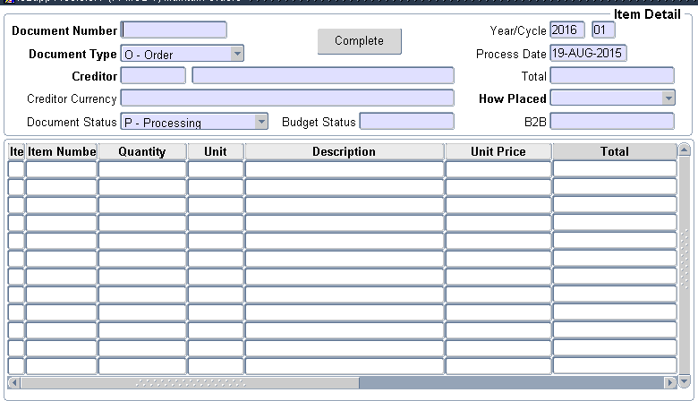

* + - Tab to generate “Document number” which has a prefix XY….
    - Tab to Creditor and select the appropriate code of the creditor to whom the order is being made.
    - Click on “Next Block”.
    - Change **Item Type** to “S” for Stock
    - Enter the fields; Item Number, Quantity and Unit Price.
    - Tab to **Cost Center or Account** and right click and select **Financial Item Detail**
    - Tab to **Account Type** and select from drop down list (eg. AP for UG Main Stores)
    - Save and exit back to the original screen.
    - Click on “Previous Block”
    - Click on “Complete” and then on view to view generated report. If the process was

successful, the report will read **XY…. has status Approval**

## FPMO2-6 (PLACE ORDER FROM REQUEST)

This is used to place orders that have gone through FPMO1-1. The menu screen is shown below.

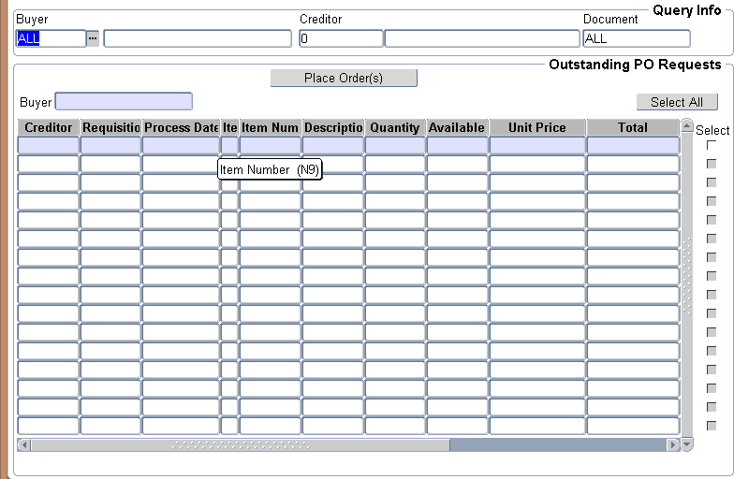

Use any of the criteria above or their combination to access the record for the order.

* + - Select any of the following or all of them:
      * **“Buyer”** (person who did the quotation maintenance)
      * **“Creditor Number”** (this is the number/code assigned to the supplier)
      * **“Document Number”** (this is the requisition number which starts with

RY…)

* Click on **“Next Block”**
* At the far right, **“tick”** against all the items being ordered under “Select”.
* Click on **“Place Order(s)”**
* Scroll to the right for the order number and write it down on the invoice **“XY….”**
* Exit.

## RECEIVING ORDERS/GOOD INTO STORES (FPMO3-1)

On delivery of the goods, the storekeeper has to receive them into stores and issue Goods Received Voucher (GRV), which is normally attached to the invoice for payment. The menu for this process is FPMO3-1 (Maintain GRV). The screen shot as shown below.

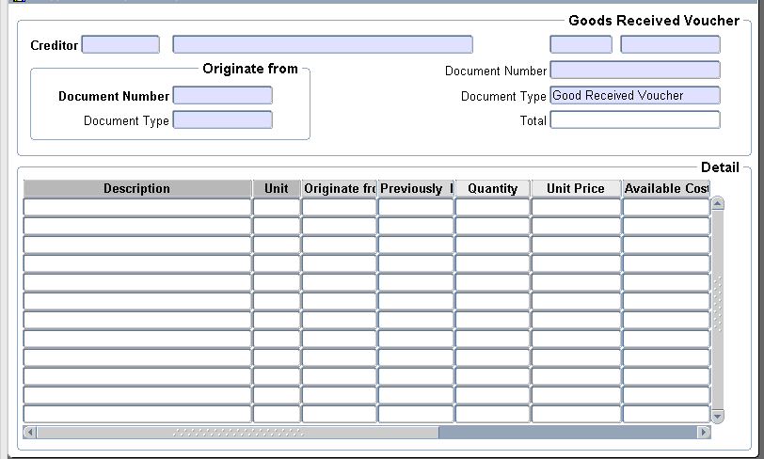

* Enter **“Creditor number”** or code of the supplier as defined on the system
* Tab to display the name
* Tab again for the system to generate the auto number for the GRV e.g. RV5488
* In the ‘**Originate from**’ box, enter the order number or open the window to select from the

**“Document number” e.g**. XY2441 (the order number written on the invoice)

* Click on **“Next Block”** to populate the list of items.
* Enter quantity supplied (as stated on the invoice).
* Check if **Unit Price** agrees with what is quoted on the invoice. If not, investigate and make the necessary enquiries.
* Save to complete the process.
* Write the GRV Number (e.g. RV4452) on the invoice and exit.

## SEARCH FOR A DOCUMENT (FPMO1-8)

This is used to check the status / stage of a requisition.

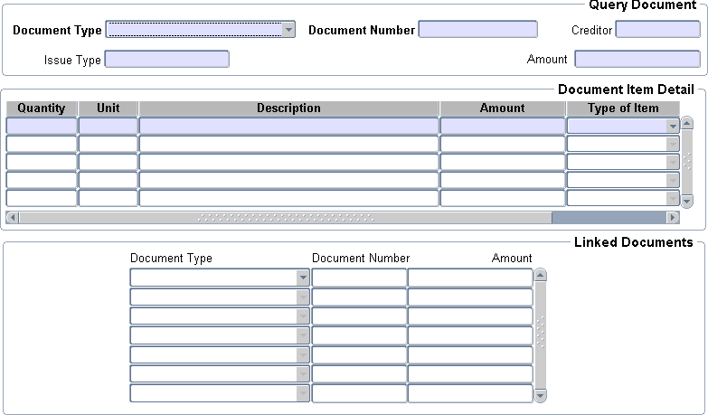

The steps are as follows:

* Enter any of the following: Block 1:
* Document Type: select the appropriate document type being processed. E.g

I – web requisition R – Request

O – Order

G – Goods received voucher

* Tab to “Document Number” and type the document number or click on the dots (…) to

select the number depending on the document type indicated. For e.g., Order – XY

Request – RY

Goods Received Voucher – RV

* Click on “Next Block”

BLOCK 2:

* + This will display the list of items ordered from the creditor populated above under the following headings:
    - Quantity
    - Unit
    - Description
    - Amount
    - Type of item
  + Click on Next Block BLOCK 3:
  + The various stages that the document has gone through would be displayed thus showing the stage reached in the processing. The stages gone through by the requisition will be shown under the following headings as shown in the attached screen shot
    - Document type
    - Document number
    - Amount

## MAINTAIN INVOICE/CREDIT NOTE (FPMO5-1)

This is used to process payment for goods and services. Goods are normally bought through stores. The supplier upon delivery of goods or service will present an invoice, which must be captured into the system to create the liability or the account payable. We will first consider the transactions that originated from the stores or the procurement unit through the ITS Integrator’s ordering system. This is processed as follows:

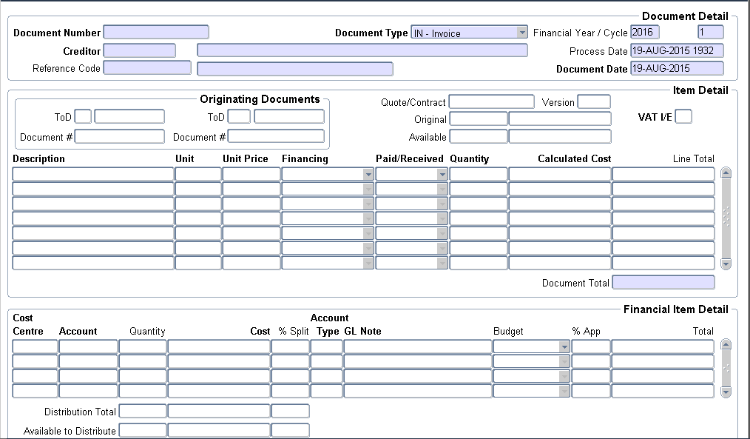

* In the space for **“Document No.”**Type in the “(VAT) Invoice Number”.
* **Document Type:** Maintain default “IN” for invoice.
* Enter the creditor number in the space for **Creditor**.
* **“Document Date”:** Should be the date on the invoice. Note that this cannot be changed once it is completed and saved.
* **“Ref. Code”:** unique code or word(s) used to identify the invoice. For instance, if the invoice is about scanners, the code could be “SCANNER”.
* Move cursor back to **“Document Number”,** right click and select **“Copy Ref. Document”**.
* Move to Next Block.
* Click on “Enter Query” and “Execute Query” icons.
* Select the applicable **Document No.** e.g. XY2441 or RY33837, and **“Tick”**

the box next to them.

* All items linked to this number will be Ticked in a box in **“Next Block”**.
* At the bottom-end of the screen, Click on **“Copy Document + Selected**

### Items”.

* EXIT
* All the ordered items and total amount payable will show. Check to ensure accuracy
* Save the document.
* It is now ready for approval and payment.

Similarly, payments can also be made to suppliers through this process without having to go through the usual procurement process. This is done as follows:

* Use MENU OPTION – FPMO5-1
* Enter the following information: BLOCK 1
  + **Document No. -** Type in the “VAT Invoice Number” or for Part- time Lecturers, use the unique code given. e.g. GEOG/25/SEM1/13
  + **Document Type –** Select the appropriate document type as per nature of transaction.
    - CR – Credit Note
    - IN – Invoice
    - PP – Prepayment
  + **Creditor Number** – The number assigned to the creditor on the ITS and can be searched for by clicking on the three dots (…).
  + **Process Date** – Date on which the invoice is being processed. It defaults from the system date, and cannot be changed.
  + **Ref. Code** - Unique code used to identify the invoice. It could be “PART- TIME” for part-time payments.
  + **Document Date** – Should be the date on the invoice. Note that this cannot be changed once it is completed and saved. It should be within the current year NOT postdated.
  + Click on **“Next block”**

BLOCK 2

Enter the following fields:

* + **Description** – Enter the description of items being paid for.
  + **Units** – standard unit of measurement. Eg EACH (for pieces), PKTS (for packet), LITRE etc.
  + **Unit Price** – Price of the item as quoted on the invoice. This may be VAT inclusive or Exclusive (“I / E”).
  + **Financing** – How the cost will be allocated amongst the beneficiary units. The default is quantity, meaning cost sharing will be based on the quantities allocated. The other options are “percentage” and “cost”.
  + **Paid/Received** – It indicates the basis used to recognize the receipt of the items. The available options are “Quantity” and “Monetary”.
  + **Quantity** – It represents the number of units received. It is only updateable if

the “Paid/Receive” value is “Quantity”.

* + **Calculated Cost** – will be calculated automatically by multiplying the quantity received by the unit price.
  + Repeat the above processes for all the other items on the invoice. The VAT rates are assigned as follows:
  + With the cursor on the “Item Description”, Right Click and select Item Detail
  + Indicate whether the unit price used is VAT inclusive (I) or Exclusive (E)
  + Enter the applicable VAT rate i.e. 0.03 for 3% or 0.175 for 17.5%.
  + Check the calculations on the right of the screen to verify the accuracy of the invoice.
  + Save and exit.
  + Move to the next item description and right-click.
  + Repeat the process for all the various line items being paid for to set the VAT rate.
  + After setting the VAT rate for all the line item, then move the cursor to the first item and click on next block.

Block 3

The third block is used to allocate cost to the cost centre and account code (GLA – General Ledger Allocation). The following information is required in this block.

1. Cost Centre Code of the spending unit
2. Account Code for the expense
3. The quantity/cost being allocated to the cost centre
4. Tab to Account Type and select the appropriate one. NOTE: The bank account to be used for the payment is driven by the Account Type. Make sure you use the code created for the Unit.
5. Go back to block 2 and select the next item if any.
6. Repeat the above processes i.e. 1-5 for all the items on the invoice.
7. Save the work.

Once the steps are completed and saved, the document will move to “approval status”.

## CREDIT NOTE AND PRE-PAYMENT TRANSACTION

We use these options (CR/PP) to make adjustments to the creditor account when there is goods return/Credit Note (CR) or prepayment (PP). The menu used for the capturing of such

transactions is the same FPMO5-1. Note that the effect of these transactions (CR/PP) is direct opposite of the invoice (IN) transaction. The “CR/PP” transactions raise a debit on the creditor account and debit the GLA on the third block.

The account code for “PP” is expected to be prepayment account (48110/48120). That means the advance payment was debited to the prepayment account. On the other hand, the “CR” transaction should go to the original expense account to reduce it.

## QUERY CREDITOR TRANSACTIONS

This option allows the user to display all year-to-date transactions for a particular creditor. The screen is already in query mode so users should just enter the creditor number and the other relevant parameters in the first block. You may tab to the next block or click on the next block icon for the records to populate in the second block of the screen. It is done as follows:

Use MENU OPTION FPMO5-30 (Query Creditor Transaction)

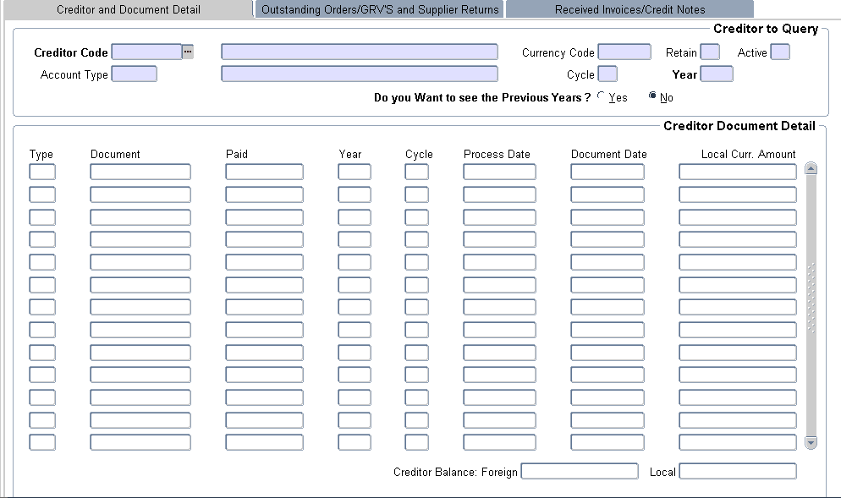

* + - Enter the Creditor Code, and tab to Account Type
    - Select account type eg. AP for the Main Administration.
    - If you want to see transaction from previous years select “Yes” against “**Do you want to**

**see the previous years?”**. If not, maintain the default “No”

* + - Move to next block
    - This will populate all the transactions for the Creditor for the specified period
    - To drill down further, right click on Document Number to show the following
      * Query Document
      * Related Documents
    - Click on Query Document
    - This will show the entries as it has been done in FPMO5-1

## APPROVING AN INVOICE

After entries for the invoice have been completed, it will move to the approval stage. On the first block the user can enter query criteria to filter unapproved accounts payable transactions awaiting approver’s action. If none is entered the system default is taken. The user may also indicate a sort order of the transactions displayed. This is done as follows:

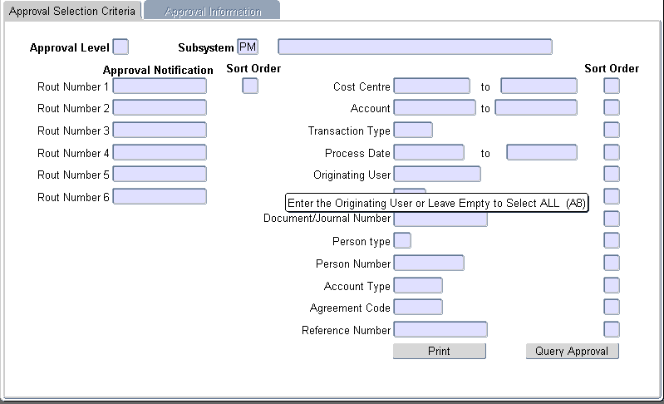

* Use MENU OPTION FPMO5-4 (Approvals)



* Enter number one ‘’**1**’’ in the Approval level
* Tab and select “PM” for the subsystem.
* You can use any of the query criteria to sort out the transactions for approval. For example, you can use the “Originating User” by entering the user code of the input clerk. The combination of the “Person Number” and “Account Type” are very useful criteria for the sorting.
* Click on “Query Approval”
* Details of the transaction(s) to approve will appear
* Check for accuracy of the transaction by highlighting it and going through the details in the window at the bottom of the screen.
* The default indicator is “A” for “Approve”. The others are “I” for Ignore and “R” for

Reject.

* I-Ignore will reserve the document for another look at it whilst the R-Reject will cancel the document outright.
* Put in the applicable indicator and click on save.
* You can use the “Approve All” or “Reject All” buttons to do a block setting for the indicator.

## CASH FLOW GENERATION-FPMOPD-1

After the approval of the invoice and the unit is ready to pay the creditor then he/she should generate the cash flow. There are two steps for this functionality.

1. Cash flow generation to authenticate the figures (Gross amount due, withholding tax, and the net amount payable).
2. Cheque(s) generation to make actual payment on account of the creditor.

The user should correct all errors when the cash flow is generated before the cheques generation is done. Users should note that at the cash flow stage the invoice can be cancelled if there are errors but beyond that the invoice cannot be cancelled. After the cheque generation, any correction could only be done by passing an entry on FPMO5-1.

FPMOPD-1 (Cash Flow/Payment Generation)

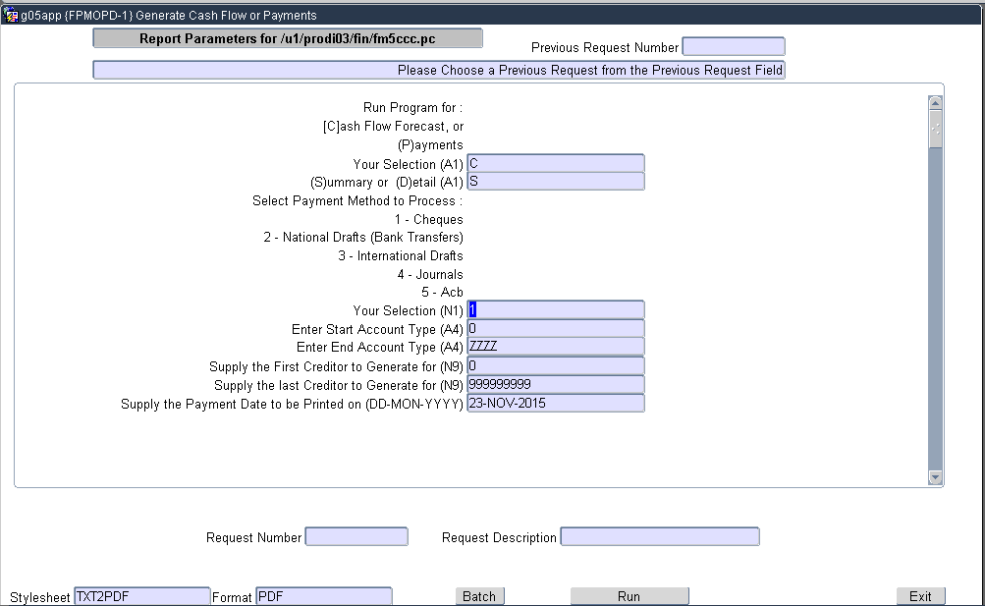

* Run FPMOPD-1
* Tab and accept “C” for cash flow first.
* Tab and indicate the report form – “S”- Summary or “D” – Detail.
* Tab and select “1” for cheques if you are generating to print cheques.
* Tab and indicate the account type you are generating the cheques for at both the start and the end account type. For example “APBS” for Business School.
* Tab and indicate the number range for the suppliers or creditors.
* Tab and accept the cheque date which is the current date.
* Tab and select “1” for payments outstanding.
* For the rest tab and accept the defaults for sort order and output type.
* Tab and run and view the report.
* Check for the accuracy of the figures and do the actual payment “P” if you are satisfied

with the output.

## CHEQUE PRINTING

After the cheque generation, the cashier can now print the checks on menu code “LFCTO” for both single cheque and continuous cheques. Note that after the preceding processes, you do not type the cheque on FCTO-6 but just direct printing.

## PAYMENTS THROUGH THE IENABLER PAYMENT REQUISITIONS USING IENABLER

Payment requisition can be raised in favour of a **creditor** due for payment using the **iEnabler**. Also, the corresponding **withholding tax** payable to Ghana Revenue Authority can be processed the same way. However, we recommend that iEnabler be used for only non-withholding tax transactions like medical refund.

**ACCESSING THE FINANCE iENABLER**

To access the Live iEnablers:

1. Go to the University website
2. Put the cursor on the Staff or Student Menu
3. Click on the **MIS Web**

*A Login screen appears for you to enter your* ***Staff/Personal Number*** *and* ***PIN***

*If you don’t know your PIN then check* ***Personnel,*** *put in your staff number, and click on*

*“Request A PIN” button. The PIN will be emailed to you via this address* [*its@ug.edu.gh*](mailto:its@ug.edu.gh)*.*

*If you are training on the Test Environment, click on the* ***Test iEnabler Icon*** *on your desktop to get to the Login Screen.*

1. At the right side of the screen (**Registered Users**), Check ***Personnel***
2. Enter your Personnel Number
3. Enter your Five-Digit numeric PIN
4. Click on **Login**

After logging in you will see two lists of iEnablers, one at the left and one on the main screen.

STEPS:

* + On the extreme left, click on **Finance iEnabler**
  + Select “**Requisitions”** from the sub-menu under **Finance iEnabler.**
  + Before you create a new requisition number,
    - Click on **“Maintain Requisitions”** to show all the requisitions numbers created in your account.
    - Click on a **“Requisition Number”,** select **“View Item Detail”** to see if there are items linked to this requisition number.
    - If there are items linked, they will be listed. However, if there are no items linked, it will show **“No items to be maintained”**
    - In this case, the requisition number can be used
  + However, if no requisition numbers exist to be maintained, click on **“Create Requisition”** to produce a unique Requisition number with a prefix **RY**.
  + Click on **“Here”**
  + Select “**Add payment Item”**
  + Select **“other”** and enter the following fields as shown below:

**Requisition: RY36452 Total: 0.00**

Other

**Creditor Type:**



**Personn**

**el Number**

**:**

**Perso**

**n Name**

**:**

Single

**\***

Multiple

**\***

**\***

**\***

**Name on Payment: * Payment**

**Note: Budget Allocatio**

**n: Payment Amount: Expense GLA:**

**Initiated**

**By:**

**Person Type:**



AF05

Clear Form

Save

* + Click on **“Here”** and do **“Budget Allocation”**
  + Click on **“Here”** and do **“Budget Control”**
  + Click on **“Here”** and **“Complete Requisition”** if there is budget for the transaction. NOTE: To make changes,
* Click on **Here** **Item Detail ** click on **Cheque Payment**
* Edit payment details as required (making changes to creditor details)
* To make changes to the **“GLA”,** Click on **Budget Allocation** and edit as required
* Once all entries are done correctly, **“Click on here”** and **“Complete Requisition”**

## VALIDATING PAYMENT REQUISITIONS

After a payment requisition has been completed, the person with the right privilege has to validate it. This involves checking to ensure the following are correct:

* Name of payee
* Amount
* Account code & Cost Centre

Validate the requisition as follows:

* Enter the ‘**MENU’ FCTO-11** (Cheque request validation). This produces a screen shot as shown below

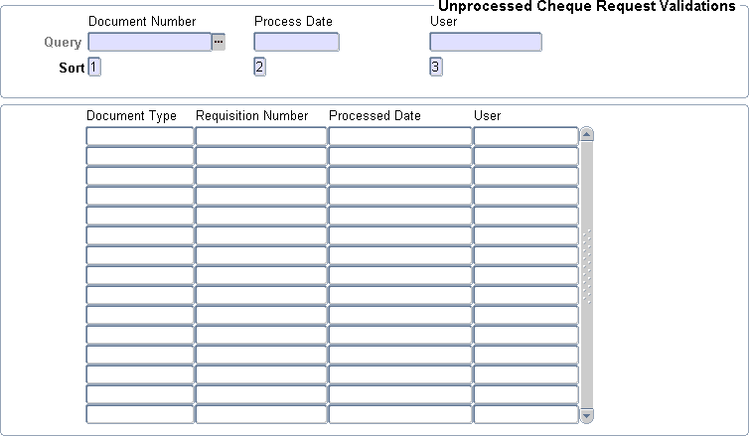

* Under **Document Number**, enter the requisition Number to validate

This starts with RY…….

* Tap to populate **Process date** and **User name**
* Move to **Next block** which shows the following
  + Document type
  + Requisition number
  + Process date
  + User
* Right click on **Requisition number** to show the following

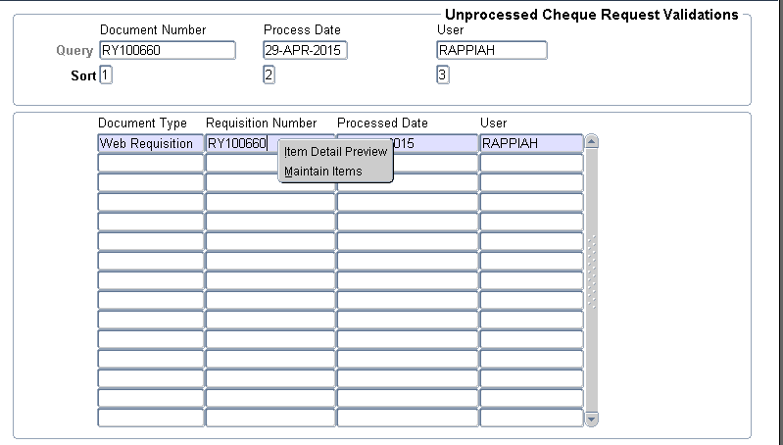

* + Maintain item preview
  + Maintain items
* Click on **Maintain items.** This opens a window which shows the following

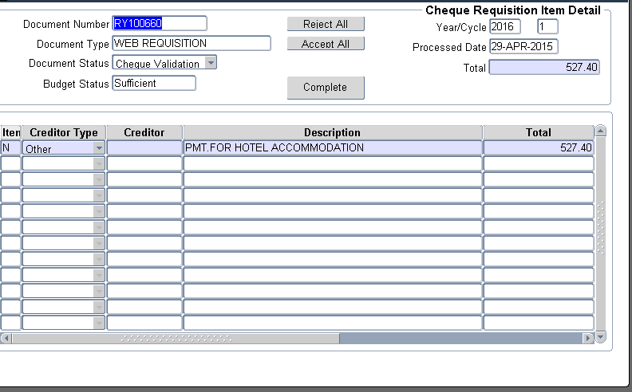

* + Item
  + Creditor type
  + Creditor
  + Description
  + Total
  + Finance
  + Cost Centre
  + Account code
  + Budget
* In the field box under **Credito**r, Right click and select **Maintain cheque requisition detail.** This produces a screen as follows:

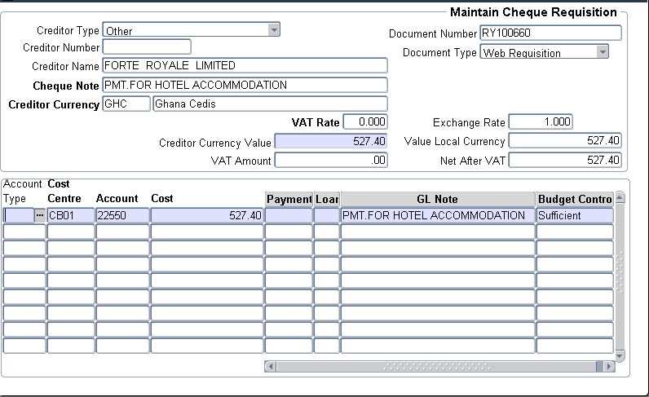

* Check to see if the entries are as required.
* In situations where there is a mistake, corrections can be done to the **Cost Centre code, Account code** and **Amount**. However, the name of the payee cannot be changed here.
* Right click on any of the code listed above and their description will appear. This helps to ensure the postings are done to the correct cost centre and account code.
* Any changes made must be saved.
* Exit to return to the previous block.
* In the box under **Item**, Right click on it to show **Reject** or **Accept** for each of the lines.
* Select the appropriate one. Alternatively, this can be done by Clicking on previous block, then select **Accept All** or **Reject All**
* Click on **Complete** to end the validation process.
* Once validated, the document now moves to the Approval Stage.

## APPROVING THE PAYMENT REQUISITION ON THE IENABLER

Only requisitions that have been validated can be approved on the web.

1. Under the Finance iEnabler click on **requisitions**
2. Click on **Approve Requisitions**. A sample of the screen is below

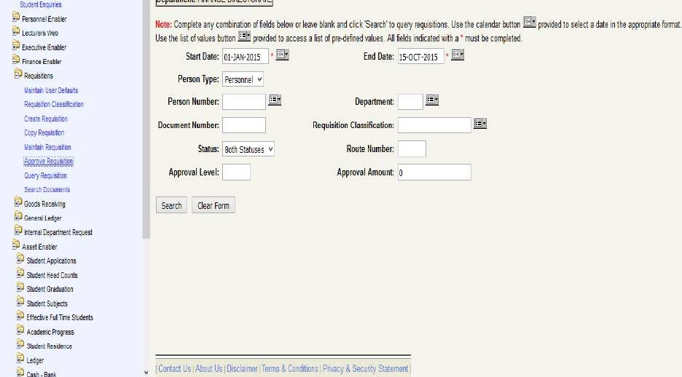

1. Click on search and all the requisition outstanding for approval will pop up.
2. You can now click on the requisition number that you want to approve.
3. The system has set the approval status of each requisition to ***reject*** by default.
4. To approve the request, simply change the Reject to Approve.
5. Then click on **Save.**

You may also decide to ignore the request.

1. To ignore the request, set the Approval Status to **ignore** and Save. This will give you access to the document again to approve or reject the request.
2. To reject the request, set the Approval Status to **Reject** and Save. This is outright cancellation of the document.

## LOADING THE DOCUMENT FOR PRINTING (FCTO-6)

After the requisition has been approved, proceed with the cheque processing by loading it through the back office menu FCTO-6 (Enter Cheque Transactions). These cheque transactions are entered as follows:

* Sign in as authorized cashier using menu option **FCTO-1 (Cashier Sign-On)**. This requires the user to enter **Cashier ID** and **Password**.
* Click on **“Save”** once completed
* Note that once the entries for the cheques are completed, the cahier for security reasons has to sign off. This is done by using Menu option **FCTO-2 (Cashier Sign-off)**

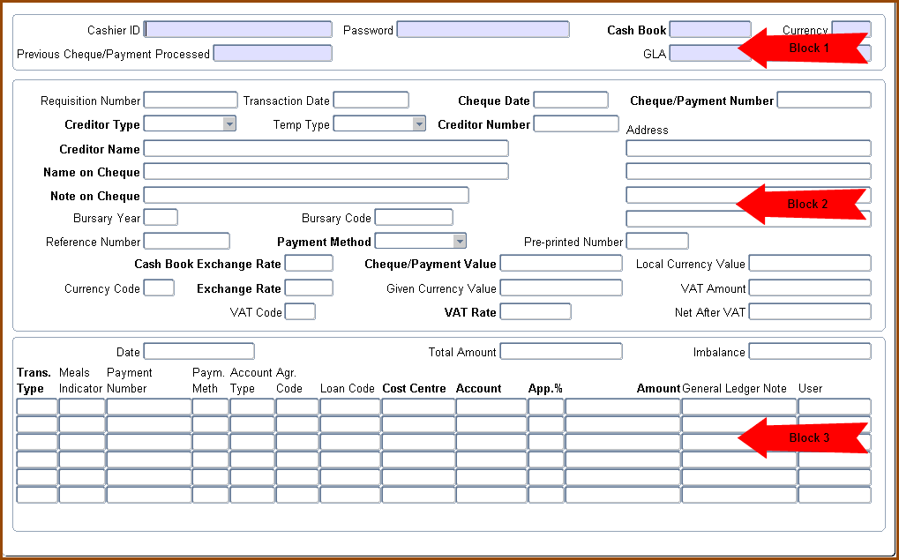

* After cashier sign-on, you can run the menu option **FCTO-6** (Enter Cheque Transactions)

### Payment Transaction Detail {FCTO-6}

* In the first block, enter the following:
  + Cashier ID – sometimes same as username
  + Cashier Password
  + Cashbook- Cash book code for the bank from which payment will be made
  + Tap to generate the Currency Code and General Ledger Allocation (GLA) i.e. Cost Centre and account codes for the cash book.

### Click on Next Block:

* Enter the **“Requisition Number-RY..”** for which cheque needs to be printed.
* Tab to show the entries as has been done in the **iEnabler**. These include:
  + Creditor type - other
  + Creditor Name – same as name that will appear on cheque
  + Name on cheque – person / company being paid
  + Note on cheque – reason for payment
  + Ref. Number – same as requisition no.
  + Payment method – Cheque
  + Payment value – amount being paid
* Also in the Third Block, the following will display.
  + Transaction type
  + Cost Centre
  + Account Code
  + Amount
  + General Ledger note
* Once satisfied with the entries, “**Click on Save”** to complete the process.

## PRINTING OF CHEQUES (LFCTO-1/2)

This has two options:

* + - Menu Option One: LFCTO-1 (Print Cheques Continuous paper). This is for printing multiple cheques with just one print command.
    - Menu Option Two: LFCTO - 2 (Print Cheques Single Paper) is used to print cheques on a single cheque leaf.

Below is the screen shot of the menu:

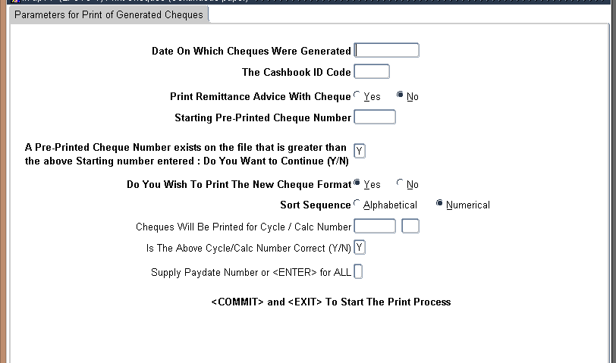

* + - Once the window is opened, enter the following:
      * Date on which cheques were generated
      * Cash book code from which cheque are being paid
      * Starting preprinted cheque number – this is the number on the cheque paper (first cheque number for continuous paper)
      * Answer Y(es) to the question that asks that there are some cheque numbers that exist that are greater than the one entered.
      * The rest will remain the same
      * Commit / Save
    - Exit, tab and click on “**Run”**
    - After the “Run” is completed, Click on “**View”** to see how the cheques will appear when printed
    - Click on the **ITS ICON** on the task bar if it has minimized**.**
    - Click on print. This produces a screen as shown below:

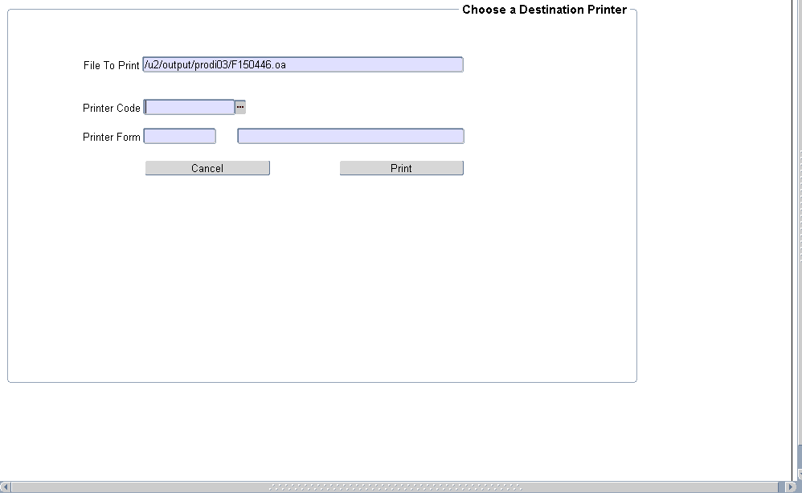

* + - Select the printer
    - Ensure that paper is properly inserted in the printer
    - Click on **“Print”.**

## STOCK ISSUES AND STOCK RETURNS

## ISSUING REQUESTED STOCK

Upon completing and approving of a requisition, the store keeper issues the item out. This is done as follows:

* + - Enter MENU OPTION FPMO4-1 (Stock Issues)

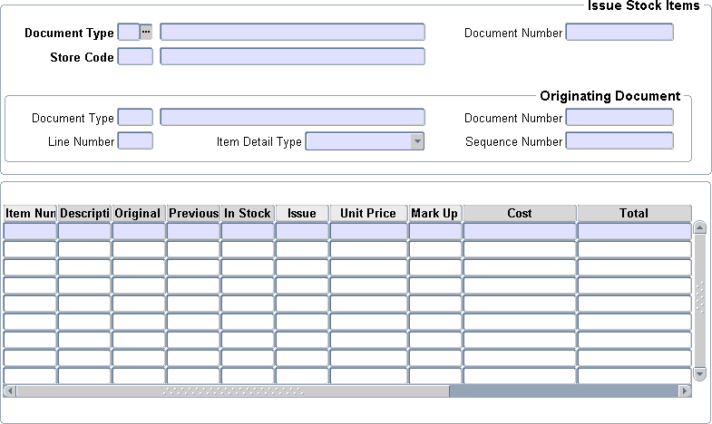

* + - Type “SA” (Normal Issue) in Document Type
    - Tap to Document Number and Tap again to generate the “Issue Number”. Take note of the number for the printing of issue voucher on FPMOR4-11.
    - Enter store code e.g. 1 for main store
    - Click on “Next Block”
    - Enter “I” in Document Type and Tab to Document Number i.e. Web Requisition number (RY..)
    - Enter the “Requisition No.” in the space provided
    - Click on Next Block to populate the requisition details as indicated below.
      * Item number
      * Description
      * In stock
      * Issue
      * Cost
      * Total
    - Under "Issue”, indicate the quantity of the items being issued
    - Save when completed
    - Note that you can do an issue without using a web requisition. In that situation you move to block three from block one and pick the items one after the other.

## RETURNING OF STOCK

Stock returns are done to correct problems with stock or store items issued. The problems include

* + - incorrect quantities issued
    - Wrong items issued.

To do this, the following processes are done:

* + - Use MENU OPTION **FPMO4-2** (Stock Returns)

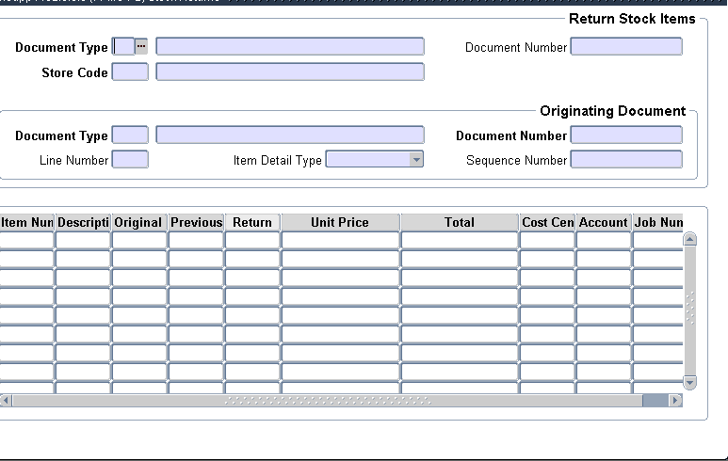

* + - In the space after **“Document Type”** enter **“TA”** and tab to generate the description

### “Departmental Return”

* + - Tab to generate the “Document Number” and write this down
    - Tab to “**Store Code**” and enter the Number e.g. “**8 for UGMS”**
    - Click on **“Next Block”** to **“Originating Document Block”**
    - Enter **“SA”** in the space provided after **“Document Type”** and tab to generate details i.e.

### “Normal Issue”

* + - Enter the **“Document Number”.** That is the issue number from the original transaction.
    - Click on **“Next Block”** to provide the following:
      * Item number
      * Description
      * Original
      * Previous
      * Return
      * Unit price
      * Total
      * Etc.
    - Type the “**quantities”** being returned in the space under return
    - The ones that you are not going to return make the return quantity zero (0).
    - **“Save”** when completed for the changes to take effect.