UNIVERSITY OF GHANA



USER MANUAL

FINANCE MODULE

BUDGETING

INTEGRATOR 1.0

FINANCE DIRECTORATE

JULY, 2015

TABLE OF CONTENTS

1. INTRODUCTION 1

1.1 OVERVIEW OF THE BUDGETING SUBSYSTEM 2

2. CAPTURING OF BUDGETED RECURRENT EXPENDITURE ON THE IENABLER 2

2.1 ACCESSING THE FINANCE iENABLER 2

3.0 MAKING CHANGES 5

4.0 ENTERING RECURRENT EXPENDITURE BUDGET ITEM USING THE BACK OFFICE 6

5.0 CAPTURING OF BUDGETED CAPITAL EXPENDITURE (FIXED ASSETS) ITEMS 7

6.0 REPORT AFTER BUDGET INPUT 11

6.1 COST CENTRE REPORT 11

6.2 CONSOLIDATED REPORT 12

6.3 MOTIVATION REPORT 13

# INTRODUCTION

**Specific Outcomes**

At the end of the training users must be able to:

* + Capture into the Finance iEnabler their budget for recurrent expenditure.
  + Capture recurrent expenditure using the back office
  + Exit while capturing a budget item and resume later
  + Revert changes to the already captured budget amounts.
  + Access the captured budget report.

## 1.1 OVERVIEW OF THE BUDGETING SUBSYSTEM

It is a planning process that enables an organisation to estimate financial resources and allocate these resources for their effective, economic and efficient gains to the benefit of the organisation as a whole.

At University of Ghana (UG), the budgeting processes have the following stages:

* Forecast revenues and allocate ceilings
* Issue of budget guidelines
* budget preparation at unit level based on allocated ceilings
* Budget entry through the ITS
* Budget hearing and defence
* Approval by Finance and General Purpose Committee
* Approval by Council
* Release of final operational budget by copying budgets to General Ledger on the ITS.

Initially, the budget entry was done only through the back office of the ITS. Users can now use the iEnabler or the ITS front office to enter their operational budget. However, for non-current assets, the back office is preferred because of the requirement of budget motivation for those items.

# CAPTURING OF BUDGETED RECURRENT EXPENDITURE ON THE IENABLER

## 2.1 ACCESSING THE FINANCE iENABLER

1. Go to the University website (www.ug.edu.gh)
2. Click on the **MIS Web**

*A Login screen appears for you to enter your* ***Staff Personnel Number*** *and* ***PIN***

*If you are training on the Test Environment, click on the* ***Test iEnabler Icon*** *on your desktop to get to the Login Screen.*

1. At the right side of the screen (**Registered Users**), Check ***Personnel***
2. Enter your Personnel Number
3. Enter your Five-Digit numeric PIN
4. Click on **Login**

**After logging in you will see two lists of iEnabler menus; one at the extreme left and one in the centre left of the main screen.**

1. On the list at the extreme left of the screen, click on the **Budgeting Module**
2. A sub list appears of which the first is **Expense Budgeting.**
3. Click on **Expense budgeting.** A sub list of the various cost centers appears.

|  |  |  |
| --- | --- | --- |
| Select the **cost center** which is applicable to the Department or Unit which you want to budget for.  The **Account Categories** are listed for you to input the budget figures. Click on the category and enter the figures. E.g. **331– SELECTION AND TRAINING EXPENSE.** A template (working sheet) with rows and columns appears on the screen as shown below.    It populates the cost centre codes, actual and budget for previous years. The entries are done into the **Total Requested Budget** and the **Cycles; from 1 through to 12.**  Under the **Total Requested budget,** type the total amount which you are budgeting. Make sure there are no comma‘s or other characters in the figure you type.  For instance if your Department or Unit made budget of Two thousand four hundred Ghana Cedi’s, for cleaning and sanitation then it will be captured as follows;  *Look for* ***Accounts code 20150, Cleaning & sanitation*** *from category 330 – Admin & General Expenses.*  *At the total requested budget type* ***2400****.*  *Then move the cursor to the cycle at which you would like the funds to be made available to your department or Unit.*  *Type the amount which you want in each cycle. E.g. If your department want to spread the 2400 equally into 2 cycles during the budget year (e.g. cycle 4 and cycle 9), it can be done as follow:*  *Under Cycle 4 for instance you will type 1200 and cycle 9 you will type 1200. It could also be done disproportionately, say cycle 1, 1400 and cycle 7, 1000.*  **Note that, it is for the discretion of the Department or unit to apportion their total requested budget into the cycles which they would like the funds to be allocated to them.**  **By default, any total requested budget amount left unapportioned to the required cycles are spread evenly to the twelve (12) cycles.**  In the example above, if the 2400 is left at the total requested budget without further apportionment to your desired cycles, the amount would be spread evenly as 200 in each cycle.  At the bottom of the working sheet for the inputting is **Save, Revert changes and Return**  After correctly doing your inputs click on **Save** to commit the work onto the server.  After **saving**, and if you are done with the current category, then click on **Return** to get another Account Category within which you have to budget for. 3.0 MAKING CHANGES You can make changes to the budget figures. Changes can also be reversed by clicking on the Revert changes at the bottom.  After making any necessary changes make sure you click on the **Save** bottom again. Click on the **Return** to exit from the working sheet. 4.0 ENTERING RECURRENT EXPENDITURE BUDGET ITEM USING THE BACK OFFICE **STEPS TO FOLLOW**  Use Menu option MEBO-3 (Maintain Requested Budget)  Enter the following required fields:   1. ***Parameter set*** *– this is the year for which the budget is being prepared. Note that in terms of academic year, parameter set code “2016” means 2015/2016 academic year from August 2015 to July 2016.* 2. *Tab to “****Start CC****” and enter the Cost Centre code for which the budget is being prepared. The CC name will pop-up automatically* 3. *Tab to “****End CC”*** *and enter the last Cost Centre code for the unit for which the budget is being prepared.* 4. *Tab to “****Start Account****” and enter the first account code for which budgeting is required. The range is from 11110.* 5. *Tab to “****End Account****” and enter the last account for which an expense will be incurred. This could be 43660*   Click on “Next block”. This opens another screen for the following entries to be done:  Cost Centre (CC) – the CC for the unit which is budgeting  Account Code – enter the code representing the expense type being budgeted for. You can click on the three dots (...) to select the account code. These codes are listed in the Chart of Accounts which can be assessed using FCSOR1-6 (Account Structure) or FCSOR1-7 and Cost Centre Codes (FCSOR1-1).  Tab to “Cycle Distribution” and click on the dots (…) to select how you want the amount to be distributed within the year  Tab to “Requested Amount” enter the total amount you are requesting for.  Note that **“Type’’** will show “E” meaning “Expense” and the “Motivation” will show “N” which means no motivation is required. This will be the case for all recurrent or operational expenses.  Use the down arrow key to move to the next budget line and repeat the process as above for other expense items.  Click on “Save” to commit the work done. 5.0 CAPTURING OF BUDGETED CAPITAL EXPENDITURE (FIXED ASSETS) ITEMS |  |  |

Capturing of capital items/fixed assets should be done using the back office but not the iEnabler because of the requirement for **Motivation.**

**STEPS TO FOLLOW**

1. Use Menu option **MEBO-3,** Maintain Requested budget
2. At the parameter set code, type the budget year. E.g. 2016

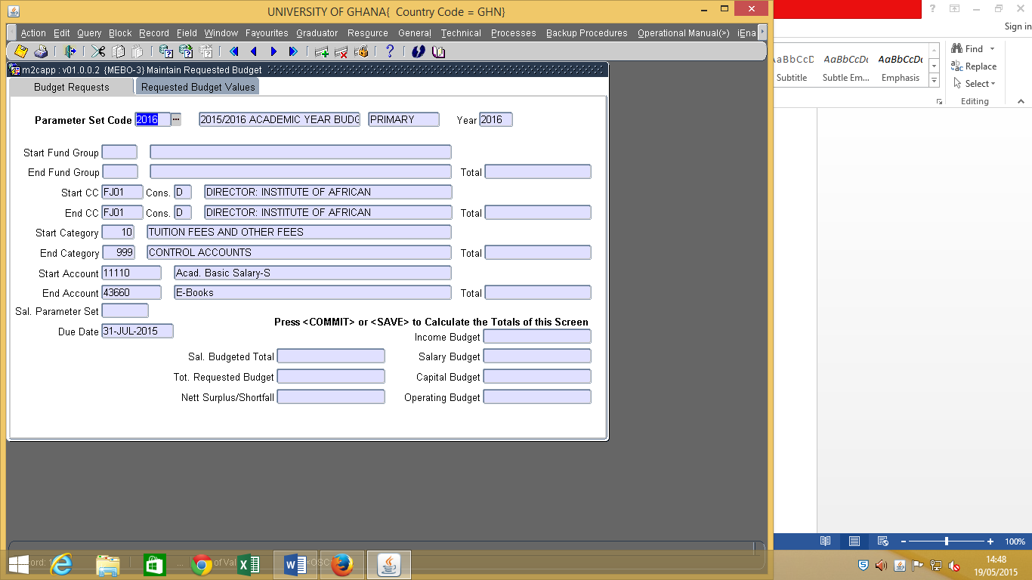.

1. Tab to Start & End CC, and type the departments or unit’s cost centre e.g. FJ01. The cost centre name will populate automatically.
2. Tab to the Start Account, and type 11110 and type 43660 into the End Account field.
3. Click on next block.

**At the next block, the following headings are seen as shown below.**

1. Type your Cost Centre, and the Account Code, e.g. 42010

Motivation will show Y,

1. Right click on the ‘Y’, to show **maintain motivation items as shown below.**
2. Click on the Maintain Motivation items. After clicking on maintain motivation items, the next block appears automatically.

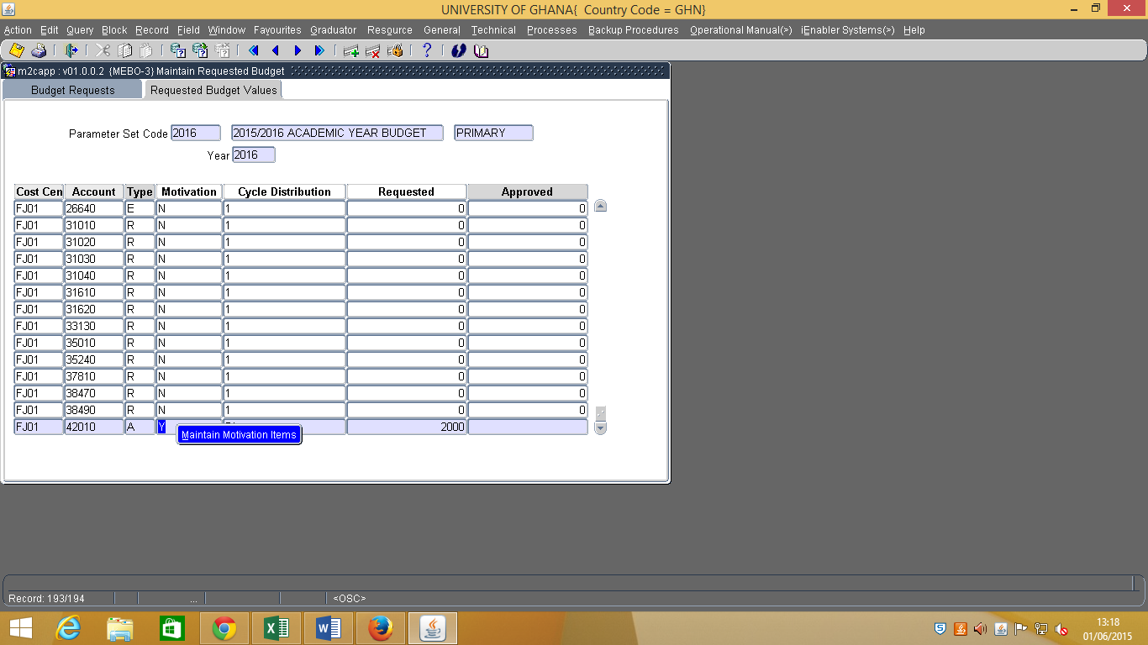

***The next block appears as seen below.***

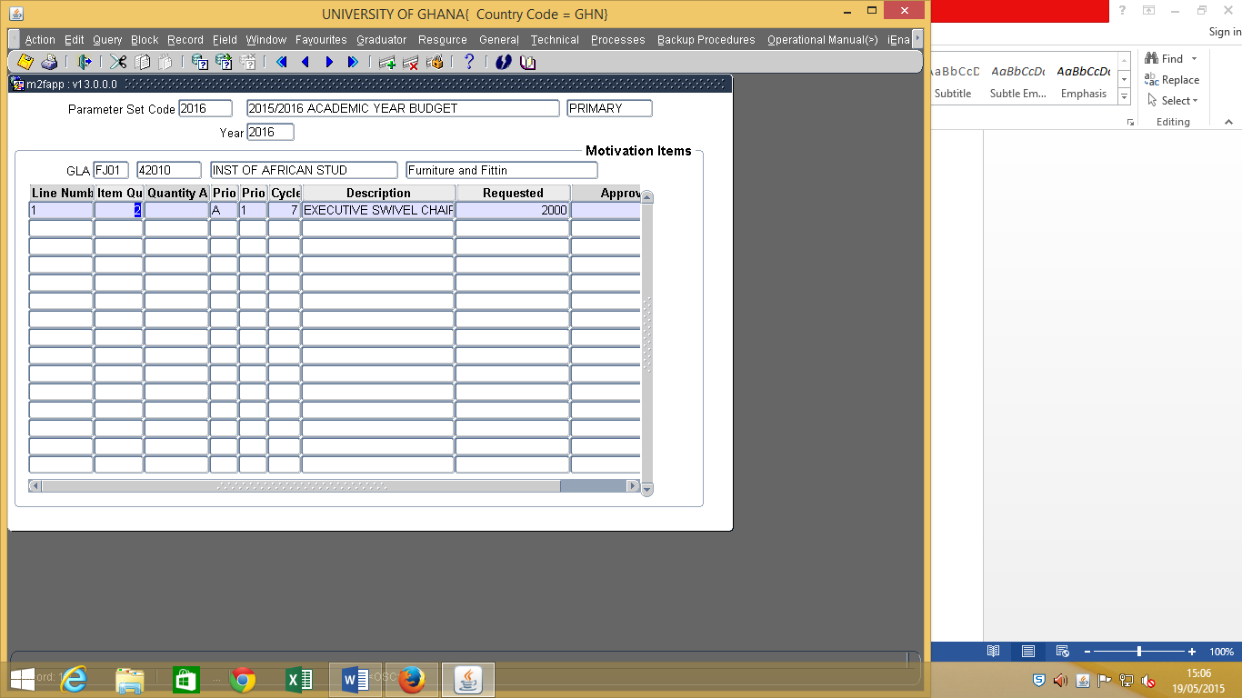

1. **Line number** is populated by the system.
2. Under **item quantity**, type the number of quantity required. E.g. 2
3. Tab to **priority level** and select A, B, or C in order of the priority at which the particular asset will be needed.
4. Tab to the **priority Number** and type a priority number (1 or 2 etc) between 1 and 99.
5. Tab to the **cycle** and type the cycle within which you will require the item.
6. Under **Description**, give a brief description of the item. E.g. Executive Swivel Chair.
7. Under **Requested**, type the total amount of budget you require for the items. **Note: The requested is not the unit price of the item.**
8. Click on **save.**

**Once you save, the next block apears.**

This screen is used to give reason(s) for the capital budget request. The line number makes reference to the previous page. It should synchronize with the item’s line number; say from 1 to 1 meaning the first capital item (Executive Swivel Chair) in the above example. If you need more than one line for the motivation then you apply the sequence parameter for the continuation of the narration. In that case you will have another line number from 1 to 1 but the sequence will be “2”.

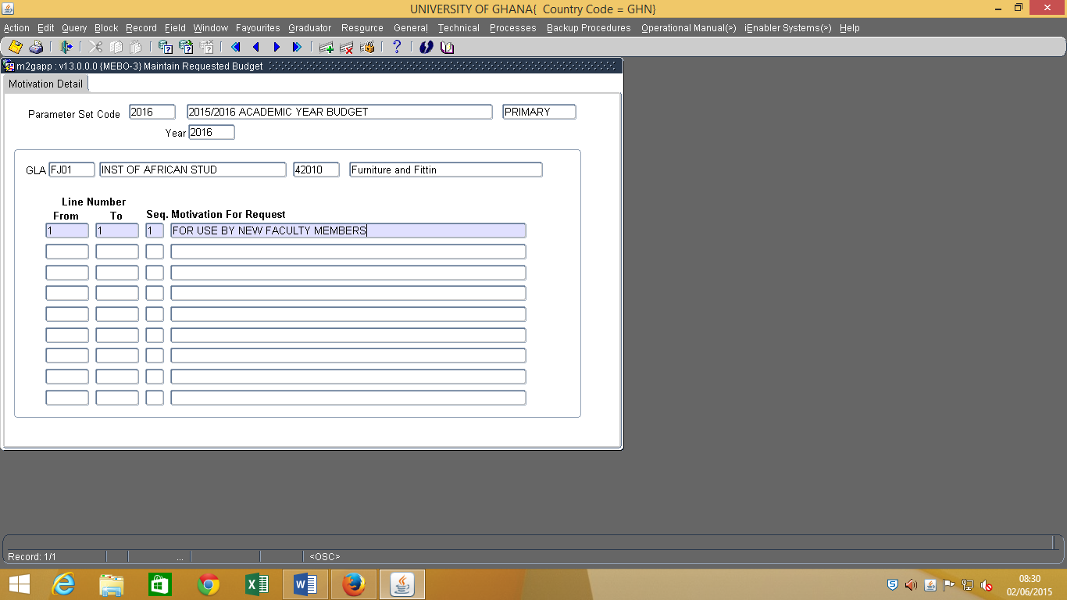

1. Tab to the Motivation for request and indicate the reason(s) for the budget item.
2. Save and exit.

***Repeat this process for other fixed assets.***

# 6.0 REPORT AFTER BUDGET INPUT

## 6.1 COST CENTRE REPORT

**The essence of this report is to give you the budget entries that you have made into the system and to make comparison between the budget items captured and that of your working papers.**

1. Use Menu option MEBOR1 -1 (Budget form/cost centre)
2. Enter the Parameter set to use e.g. 2016.
3. Tab to maintain the default start and end department.
4. Tab to also maintain the default start and end fund group.
5. Tab to maintain the default start and end category.
6. Tab to select cost center and type “1” or “2” depending on whether you want range or list of cost centres.
7. Tab to enter the range or list of cost centre e.g. FJ01
8. Tab to enter the start Account e.g. 11110 and the end Account e.g. 43660
9. Tab to maintain the default ‘N’ as No to include accounts where budgets are null
10. Tab to maintain the default ‘N’ or ‘Y’ as No or Yes to print YTD figures
11. And tab to maintain the default ‘E’ or ‘I’ to exclude/include adjustments in the report
12. Tab to Run and click on view for the report.

**Sample of the process can be seen below**

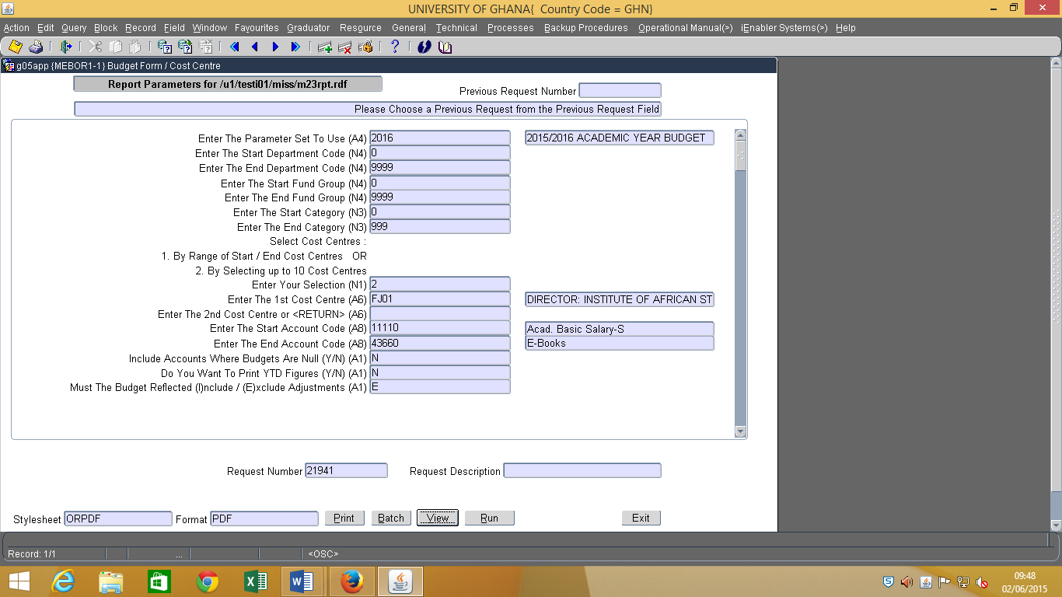

## 6.2 CONSOLIDATED REPORT

**The essence of this report is to give you the consolidated form of the budget entries that you have made into the system and to make comparison between the budget items captured and that of your working papers.**

1. Use Menu option MEBOR1-2 (Budget form/Consolidated CC)
2. Enter the Parameter set to use e.g. 2016.
3. Tab to enter the consolidated cost centre. E.g. FJZZ
4. Tab to also maintain the default start and end fund group.
5. Tab to maintain the default start and end category.
6. Tab to enter the start Account e.g. 11110 and the end Account e.g. 43660
7. Tab to the next field and type ‘D’ for a Detail Report
8. Tab to maintain the default ‘N’ or ‘Y’ as (N)o will not include accounts where budgets are null
9. Tab to maintain the default ‘N’ or ‘Y’ as (N)o will not print YTD figures
10. Tab to maintain the default ‘E’ to exclude adjustments in the report
11. Tab to Run and click on view for the report.

**Sample of the process can be seen below**

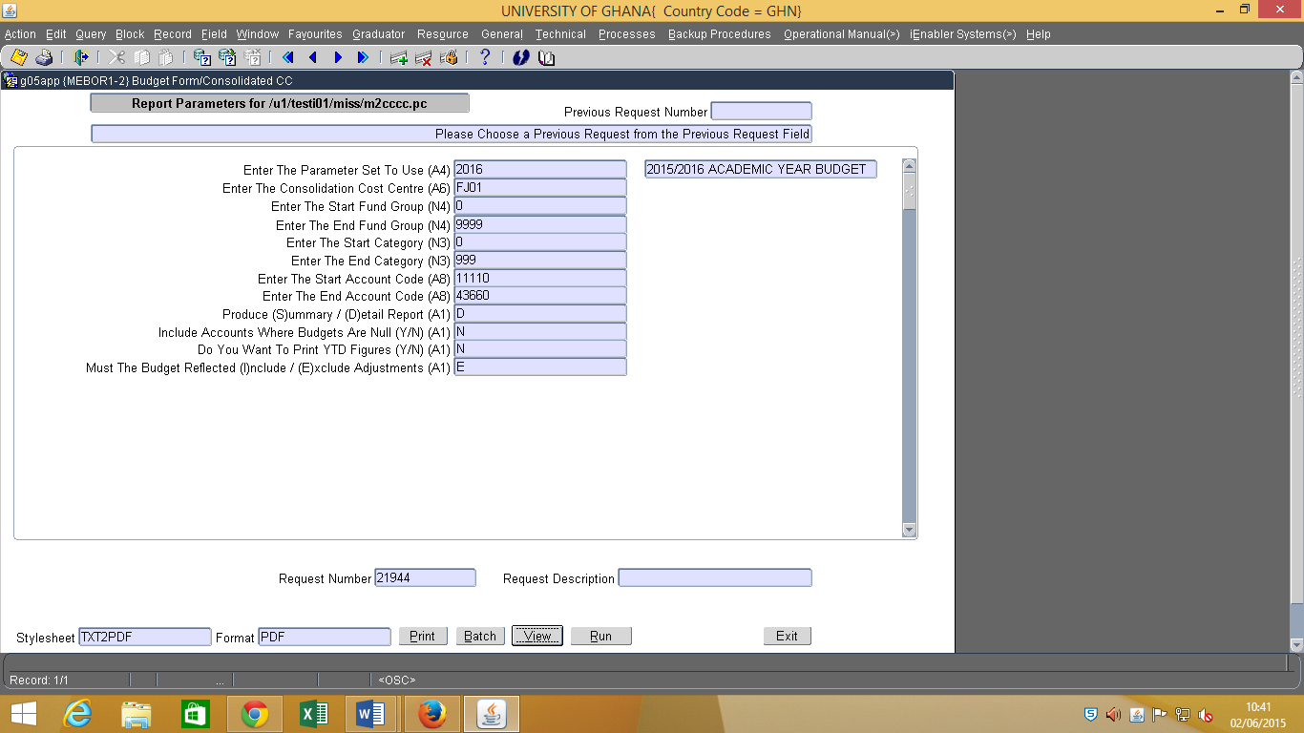

## 6.3 MOTIVATION REPORT

***The essence of this report is to access the budget captured specifically for non-current assets (fixed assets)***

1. Use Menu option MEBOR1-26 (Budget Item motivation Report)
2. Enter the Parameter set to use e.g. 2016.
3. Tab to the next fields and enter the start and end cost centre. E.g. FJ01
4. Tab to maintain the default A and Z at start priority and at end priority respectively
5. Tab to maintain the default start and end cycle 1 to 12 or enter the specific cycle you require. Note, you can change the circle to a specific cycle which you prefer. E.g Cycle 6 to 6.
6. Tab to maintain the default ALL for the report to include both approved and not approved budget items. Or enter **‘A’ f**or **only approved budget or ‘N’** for **not approved budget.**
7. Tab to run and view the report.

***Sample of the process is seen below***

