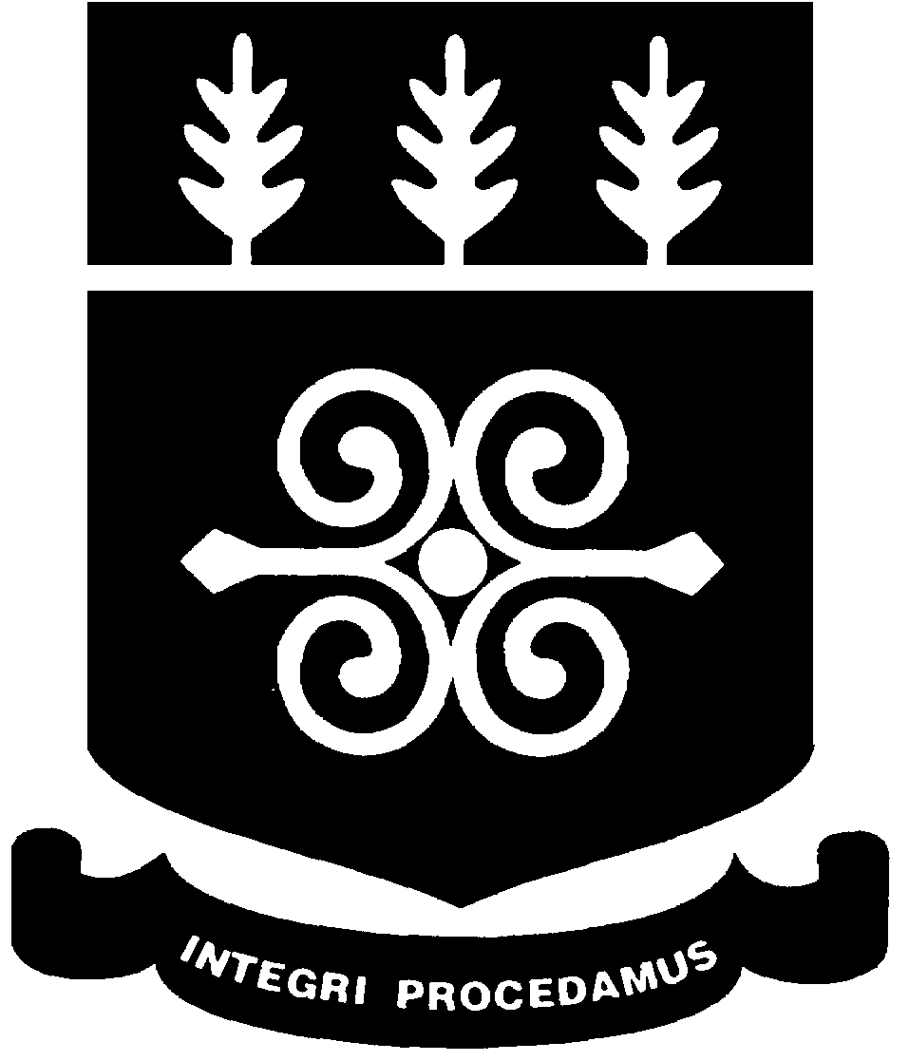
2nd Biennial
PUBLIC LECTURE
THEME: Stroke in Children in Ghana
Thursday, November 26, 2015 British Council Hall 4:00pm - 7:00pm

UNIVERSITY OF GHANA
COLLEGE OF HEALTH SCIENCES

Speakers | Topics
Dr. Catherine Segbefia - Paediatric Haematologist/Oncologist, HoD, Paediatric Haematolog and Sickle Cell Clinic, KBTH | Big Strokes in Little Folks
Dr. Lydia Aziato - Lecturer, Department of Adult Health, School of Nursing, CHS, UG | Caring for the informal Carer of Children with Stroke: Nursing Implications
Ms. Anna Hughton - Immediate Past HOD, Department of Physiotherapy, SBAHS | Rehabilitation Potentials in Children with Stroke:  The Physiotherapists’ Mandate
Mr. Peter O. Ndaa - Occupational Therapist and Co-coordinator of OT Programme, SBAHS | Stroke in Children: The Role of Occupational Therapy
Mr. Clement Amponsah - Assistant Lecturer, Department of Audiology, Speech and Language Therapy, SBAHS | Paediatric Stroke And Its Related Communication and Swallowing Disorders: Insights from a speech and Language Therapist
Chairman: Professor Ernest Aryeetey, Vice-Chancellor

The University Community is Cordially Invited

